Longitudinal stability of cortical grey matter measures varies across brain regions, imaging metrics, and testing sites in the ABCD study

Supplementary figures

**Supplementary Figures**

This document includes supplementary visualisations not included in the main manuscript. For brevity, and because Cortical thickness showed the greatest variation in stability across brain regions, we present only cortical thickness results in the main text.

Here, we present the visualisations for surface area and grey matter volume compatible with figures 4 and 5 in the main text.

Further, for the model comparison results (in which we present delta CFI in figure 7 for cortical thickness only) we present the delta AIC, delta BIC, and Chi square results here, as well as delta AIC, BIC, Chi square, and CFI for surface area and volume.

Finally, in our follow-up multigroup analyses by MRI scanner manufacturer analyses we recreated the variance decomposition (by brain region and by scanner) – compatible with figures 4 and 5 in the main text. We also re-ran the multigroup analyses for each scanner and each brain measure, and present the visualisations here – for compatibility with figure 7 in the main text.

Each figure presented here includes a description relating the analyses to the main text, with the core information in **bold**

**Supplementary Data**

Figure4_CT_scanners.png

Between-subjects (left panel), error variance estimates (middle panel), and median ICC (right panel) for each region of interest (y-axis) **for cortical thickness**. Regions are ordered by the median between-subjects variance. For clarity we present only the right hemisphere regions. **Each point represents a different MRI scanner**, and the colour mapping is the same as in Figure 5. The boxplots present the median and the 25th and 75th percentiles, the whiskers extend at a maximum to 1.5 times the interquartile range from the box.

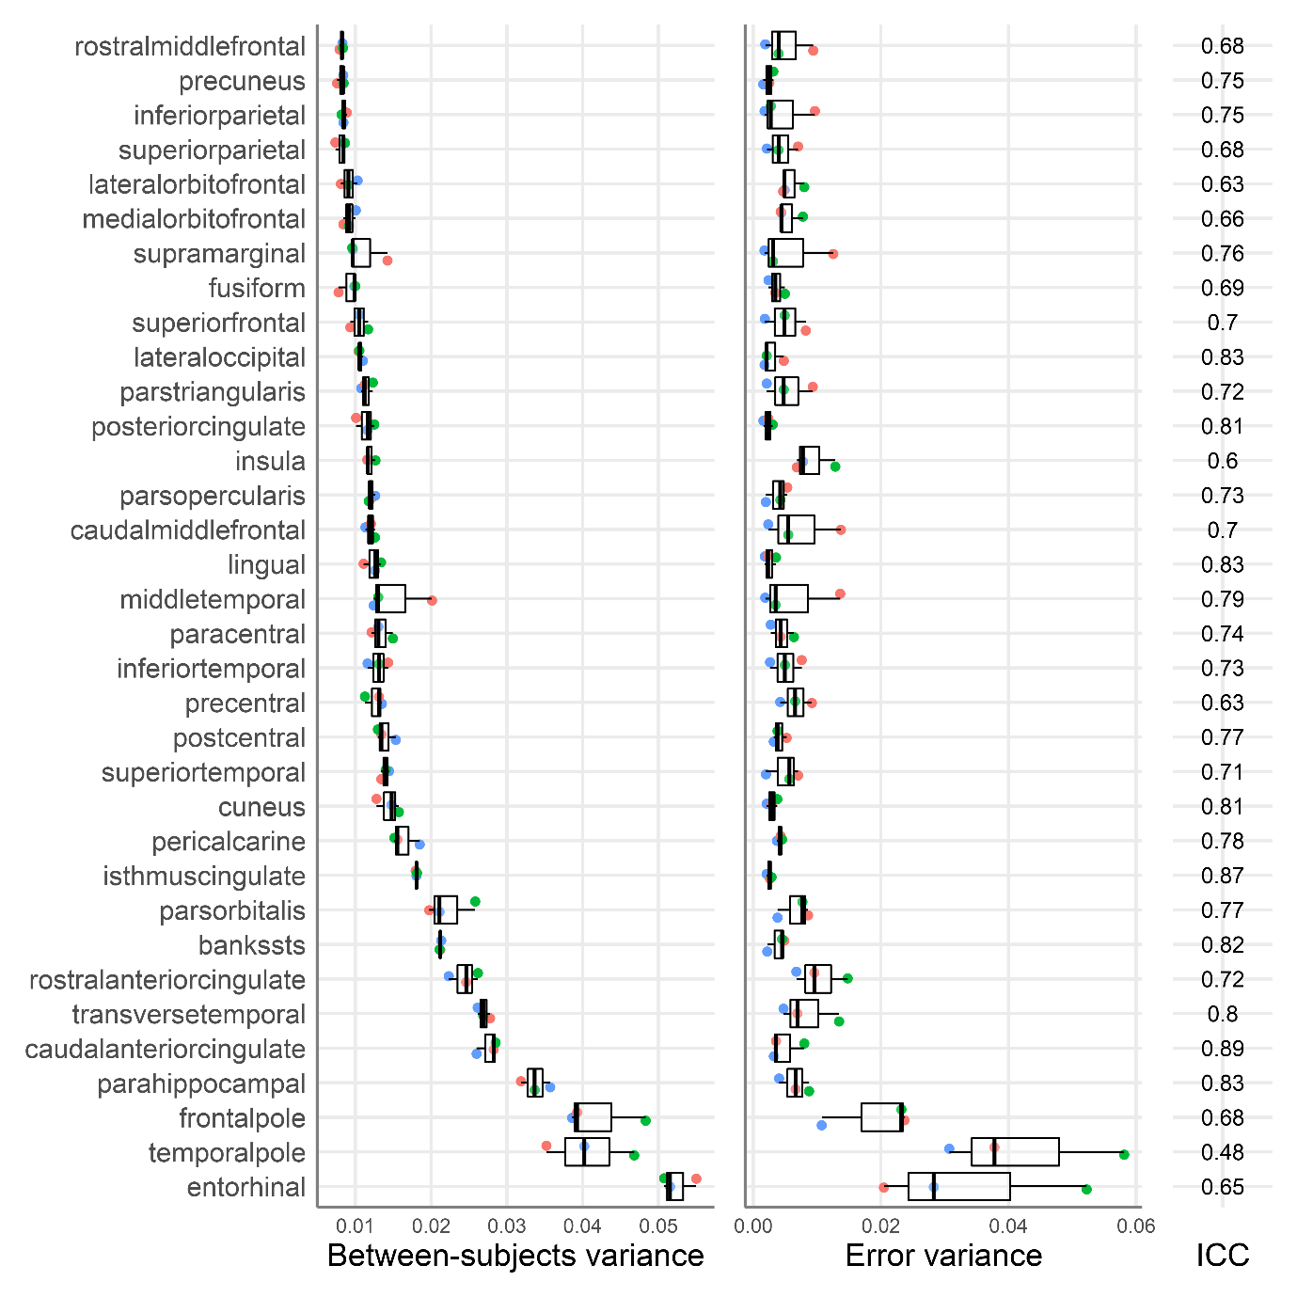

Figure4_GM.png

Between-subjects (left panel), error variance estimates (middle panel), and median ICC (right panel) for each region of interest (y-axis) **for Grey Matter Volume**. Regions are ordered by the median between-subjects variance. For clarity we present only the right hemisphere regions. Each point represents a different testing site, and the colour mapping is the same as in Figure 5. The boxplots present the median and the 25th and 75th percentiles, the whiskers extend at a maximum to 1.5 times the interquartile range from the box.

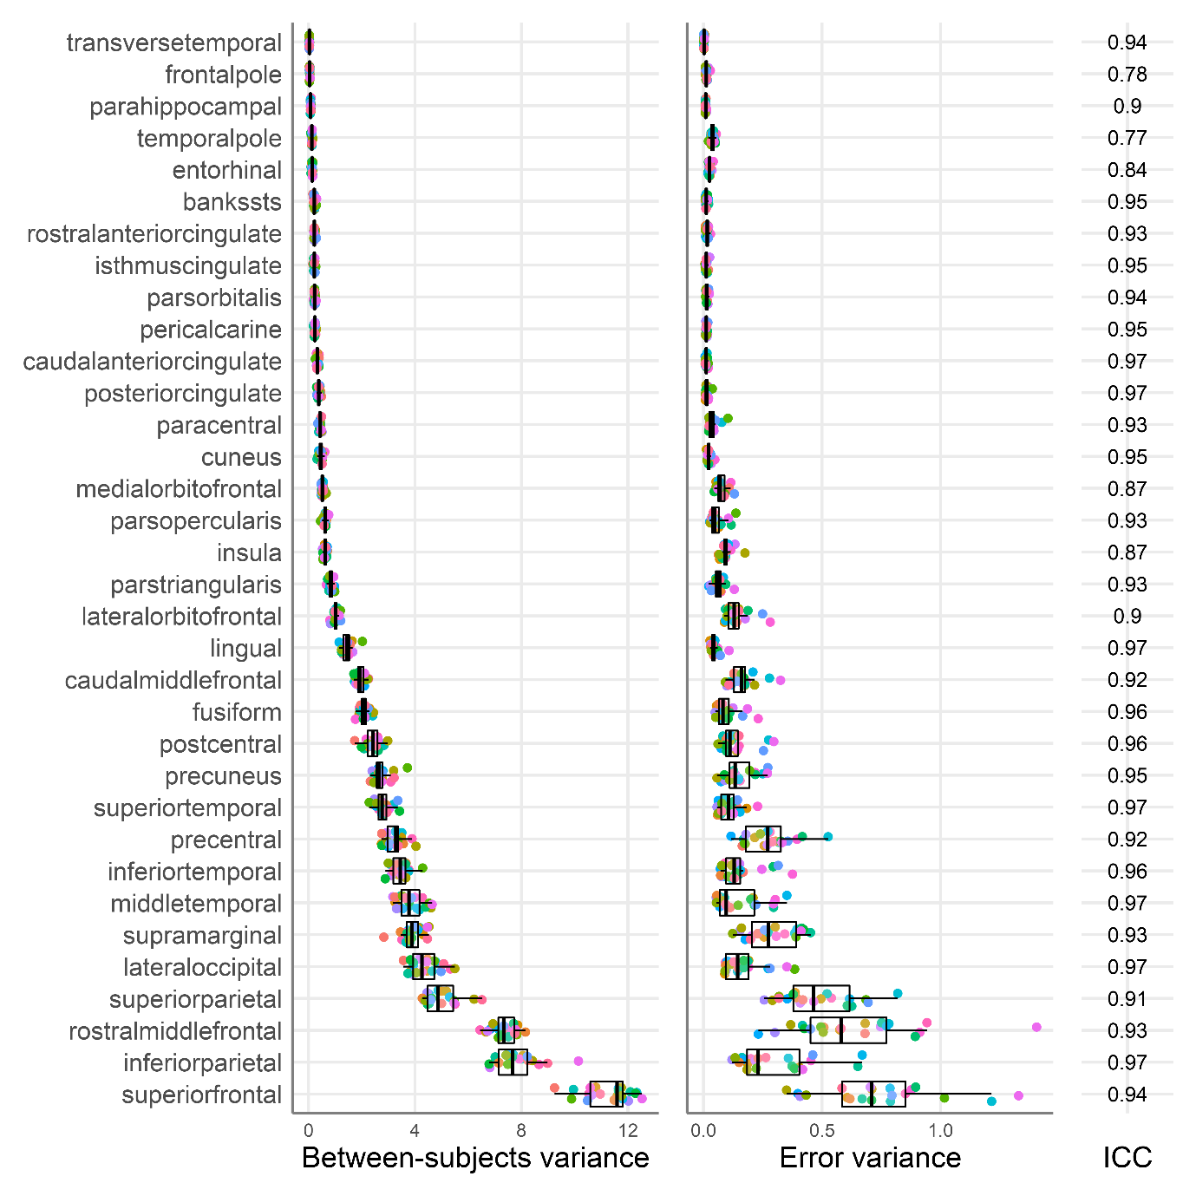

Figure4_GM_scanners.png

Between-subjects (left panel), error variance estimates (middle panel), and median ICC (right panel) for each region of interest (y-axis) **for Grey Matter Volume**. Regions are ordered by the median between-subjects variance. For clarity we present only the right hemisphere regions. **Each point represents a different MRI scanner**, and the colour mapping is the same as in Figure 5. The boxplots present the median and the 25th and 75th percentiles, the whiskers extend at a maximum to 1.5 times the interquartile range from the box.

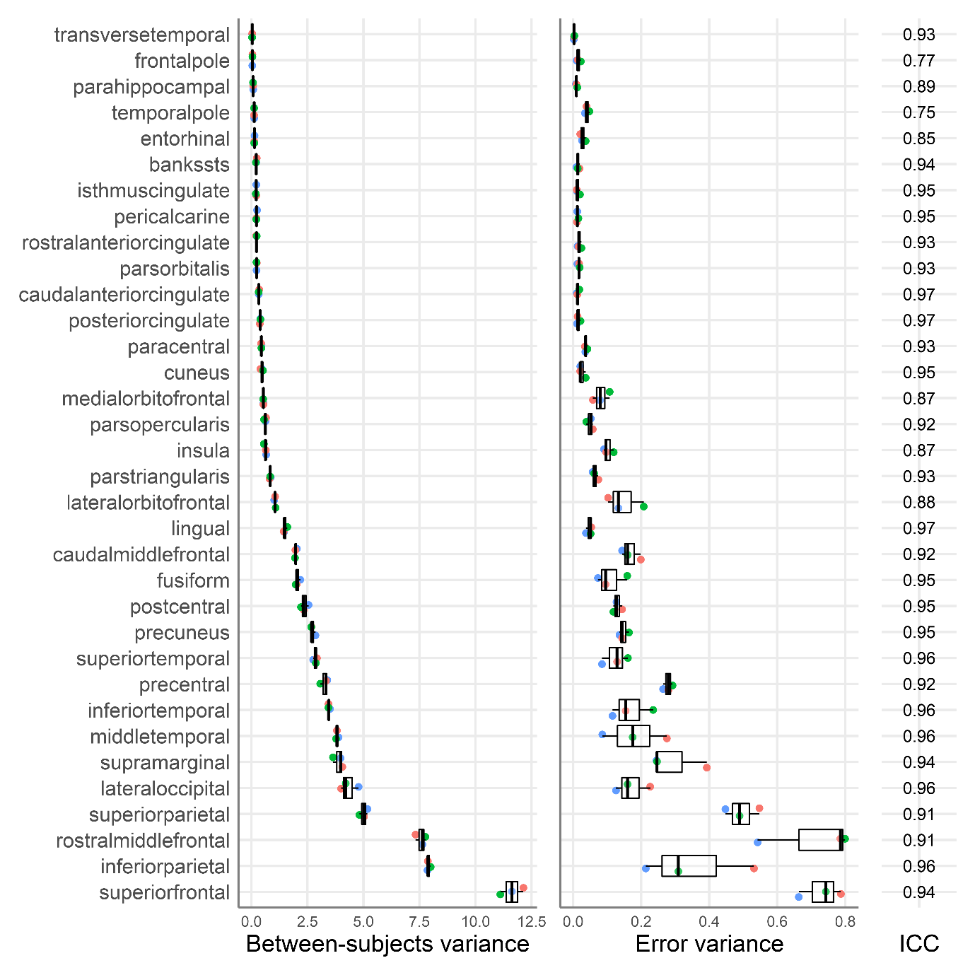

Figure4_SA.png

Between-subjects (left panel), error variance estimates (middle panel), and median ICC (right panel) for each region of interest (y-axis) **for Surface Area**. Regions are ordered by the median between-subjects variance. For clarity we present only the right hemisphere regions. Each point represents a different testing site, and the colour mapping is the same as in Figure 5. The boxplots present the median and the 25th and 75th percentiles, the whiskers extend at a maximum to 1.5 times the interquartile range from the box.

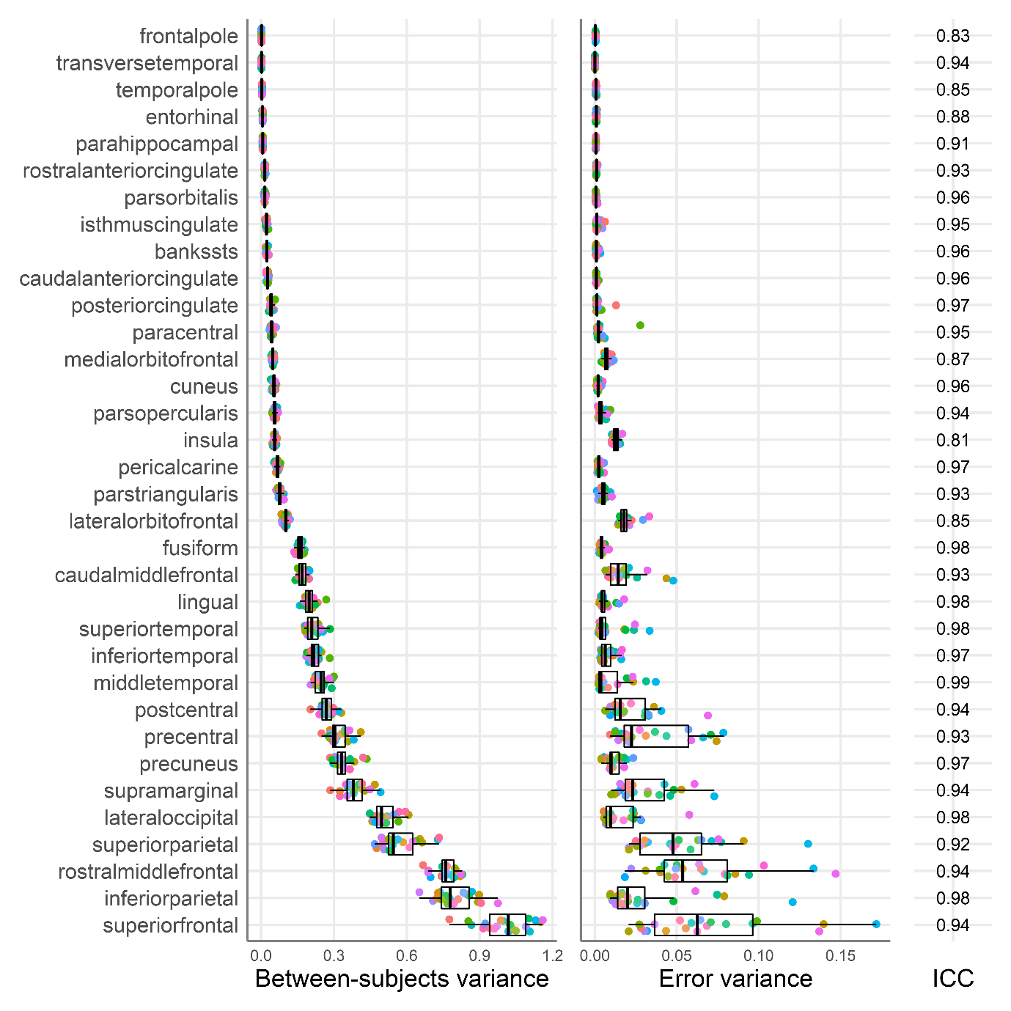

Figure4_SA_scanners.png

Between-subjects (left panel), error variance estimates (middle panel), and median ICC (right panel) for each region of interest (y-axis) **for Surface Area**. Regions are ordered by the median between-subjects variance. For clarity we present only the right hemisphere regions. **Each point represents a different MRI scanner**, and the colour mapping is the same as in Figure 5. The boxplots present the median and the 25th and 75th percentiles, the whiskers extend at a maximum to 1.5 times the interquartile range from the box.

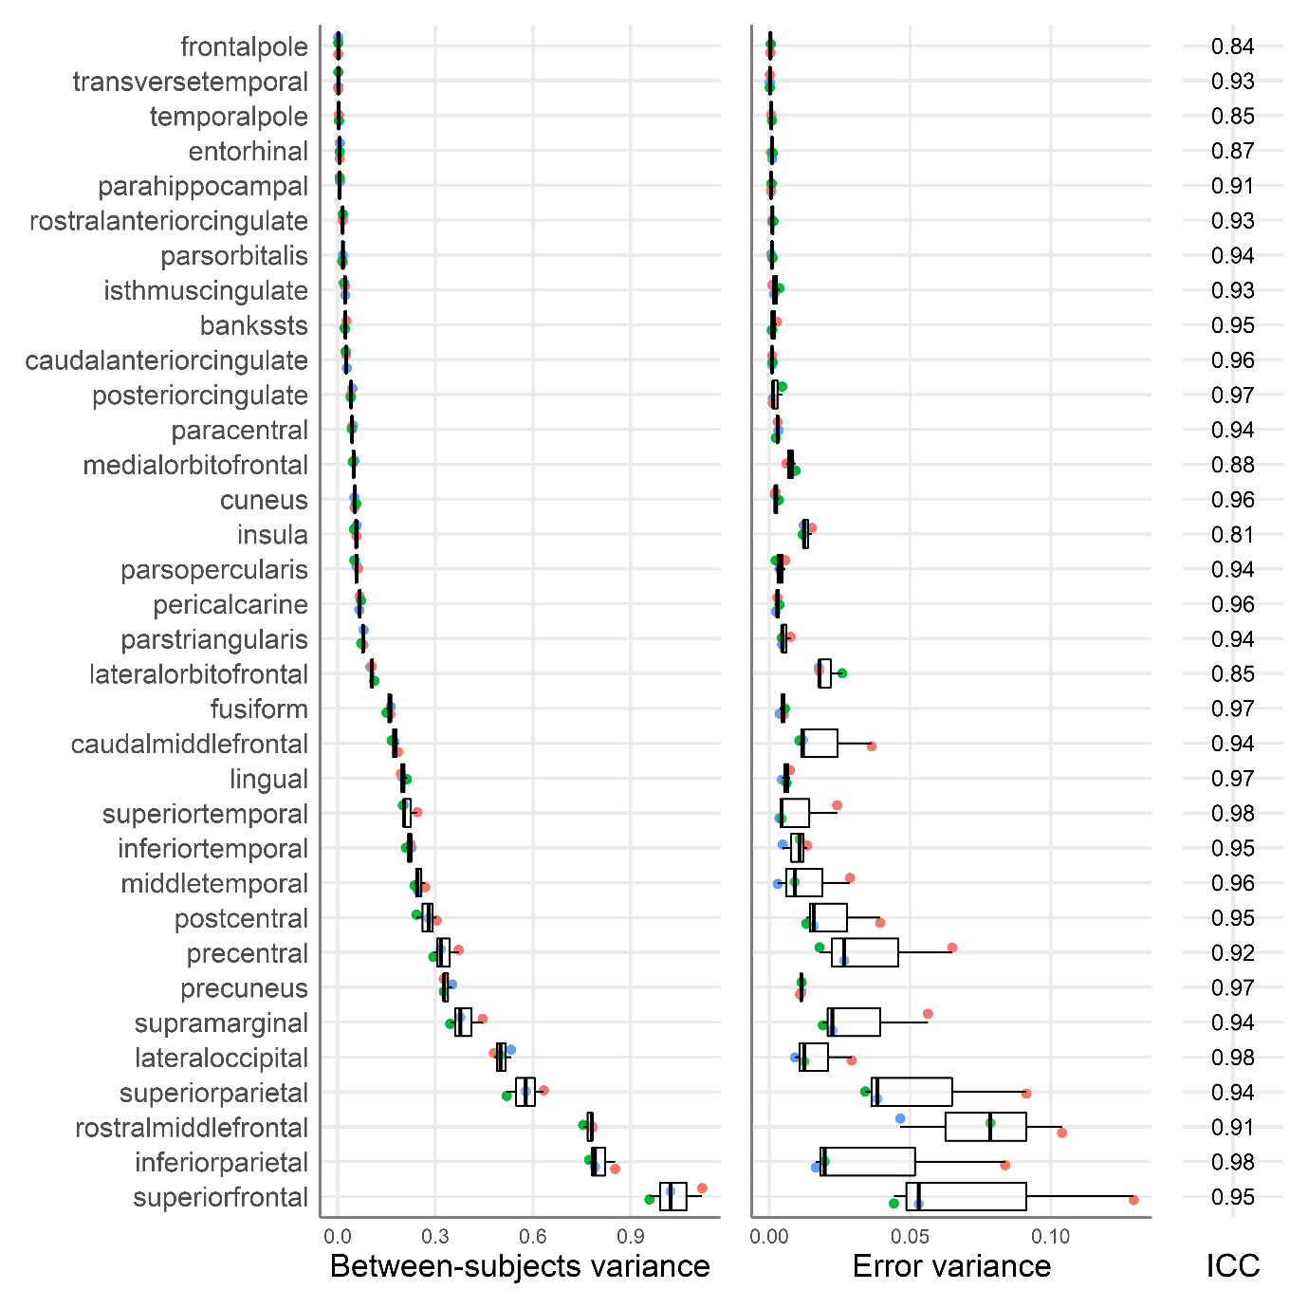

Figure5_CT_scanners.png

Between-subjects (left panel) and error variance (middle panel) estimates for **Cortical Thickness**, **separately per MRI scanner**. **Scanners are ordered by the median error variance**. Each point represents a different ROI, and the site colour maps to Figure 4. Cortical thickness only. The boxplots present the median and the 25th and 75th percentiles, the whiskers extend at a maximum to 1.5 times the interquartile range from the box.

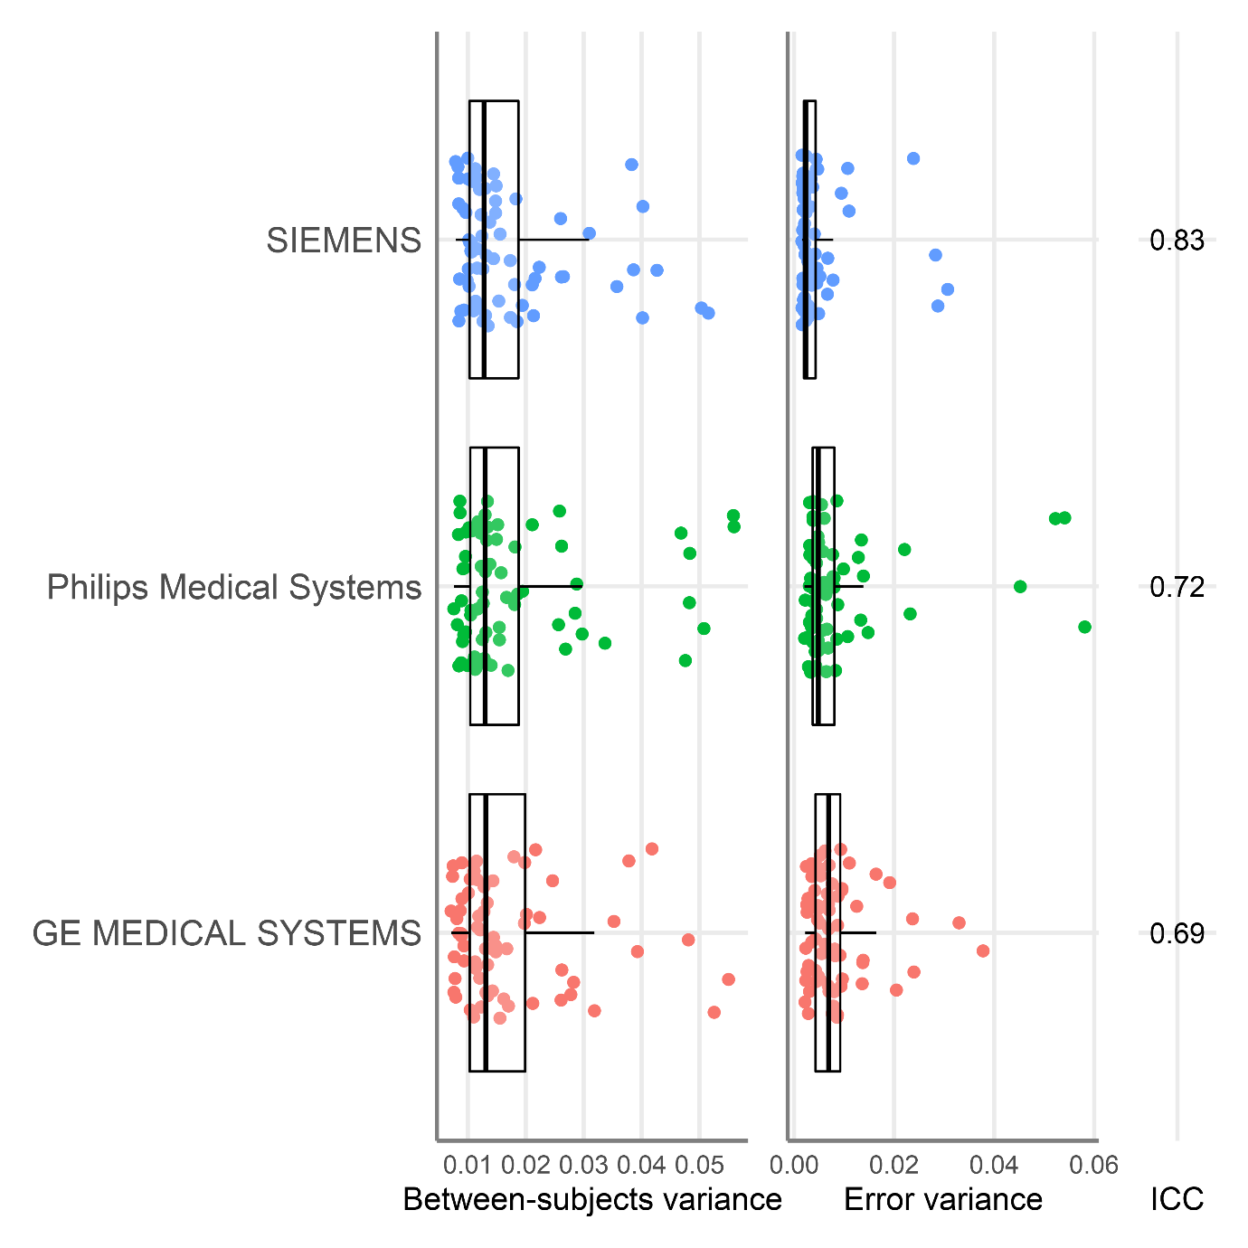

Figure5_GM.png

Between-subjects (left panel), error variance (middle panel) estimates, separately per testing site for **Grey Matter Volume**. Sites are ordered by the median error variance. Each point represents a different ROI, and the site colour maps to Figure 4. Cortical thickness only. The boxplots present the median and the 25th and 75th percentiles, the whiskers extend at a maximum to 1.5 times the interquartile range from the box.

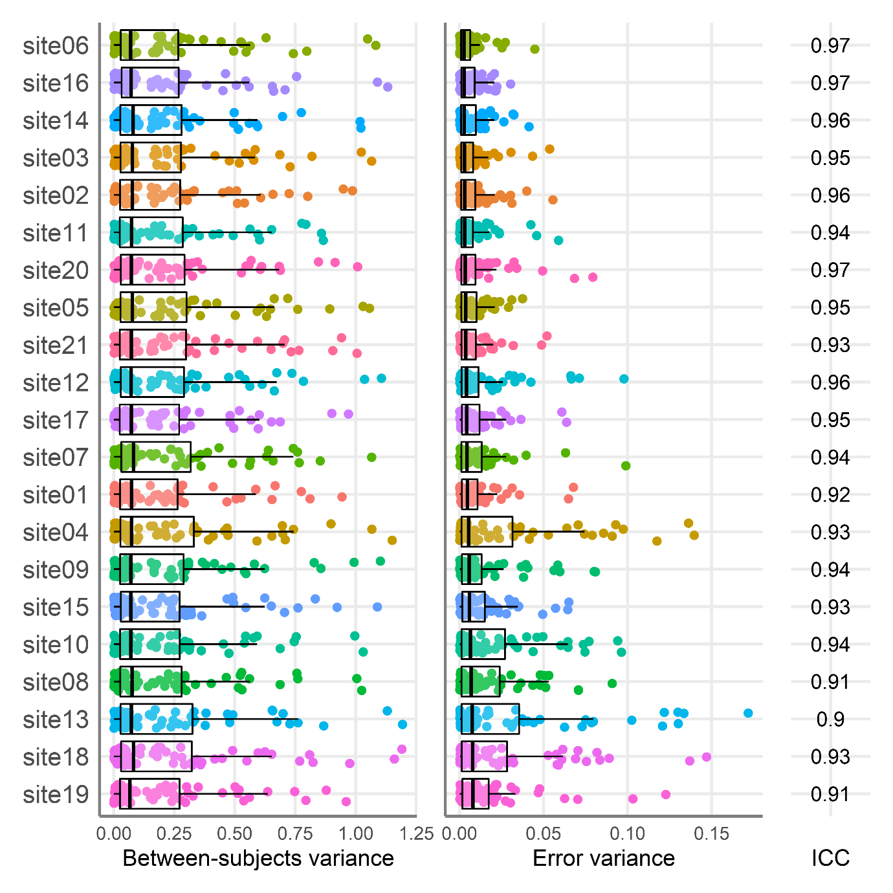

Figure5_GM_scanners.png

Between-subjects (left panel) and error variance (middle panel) estimates for **Grey Matter Volume**, **separately per MRI scanner**. **Scanners are ordered by the median error variance**. Each point represents a different ROI, and the site colour maps to Figure 4. Cortical thickness only. The boxplots present the median and the 25th and 75th percentiles, the whiskers extend at a maximum to 1.5 times the interquartile range from the box.

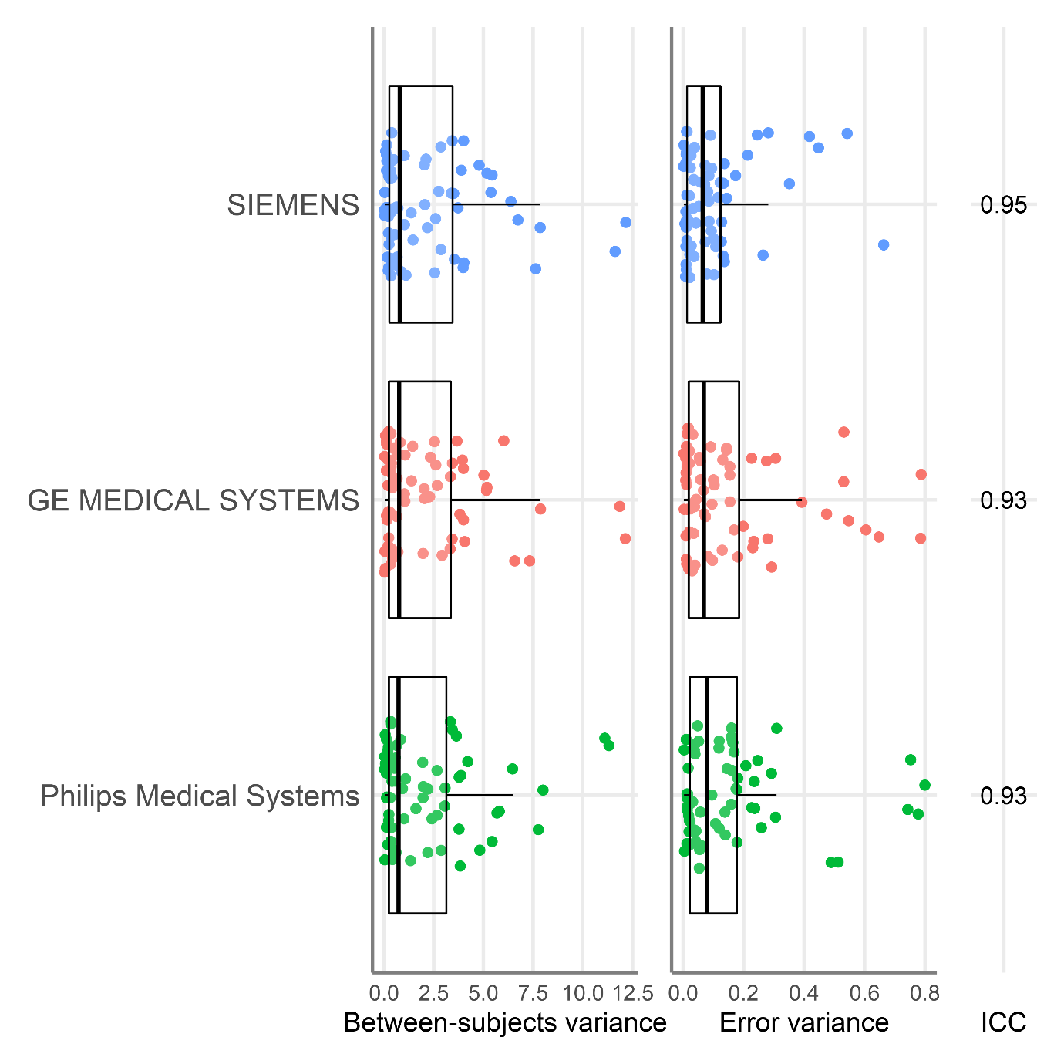

Figure5_SA.png

Between-subjects (left panel), error variance (middle panel) estimates, separately per testing site for **Surface Area**. Sites are ordered by the median error variance. Each point represents a different ROI, and the site colour maps to Figure 4. Cortical thickness only. The boxplots present the median and the 25th and 75th percentiles, the whiskers extend at a maximum to 1.5 times the interquartile range from the box.

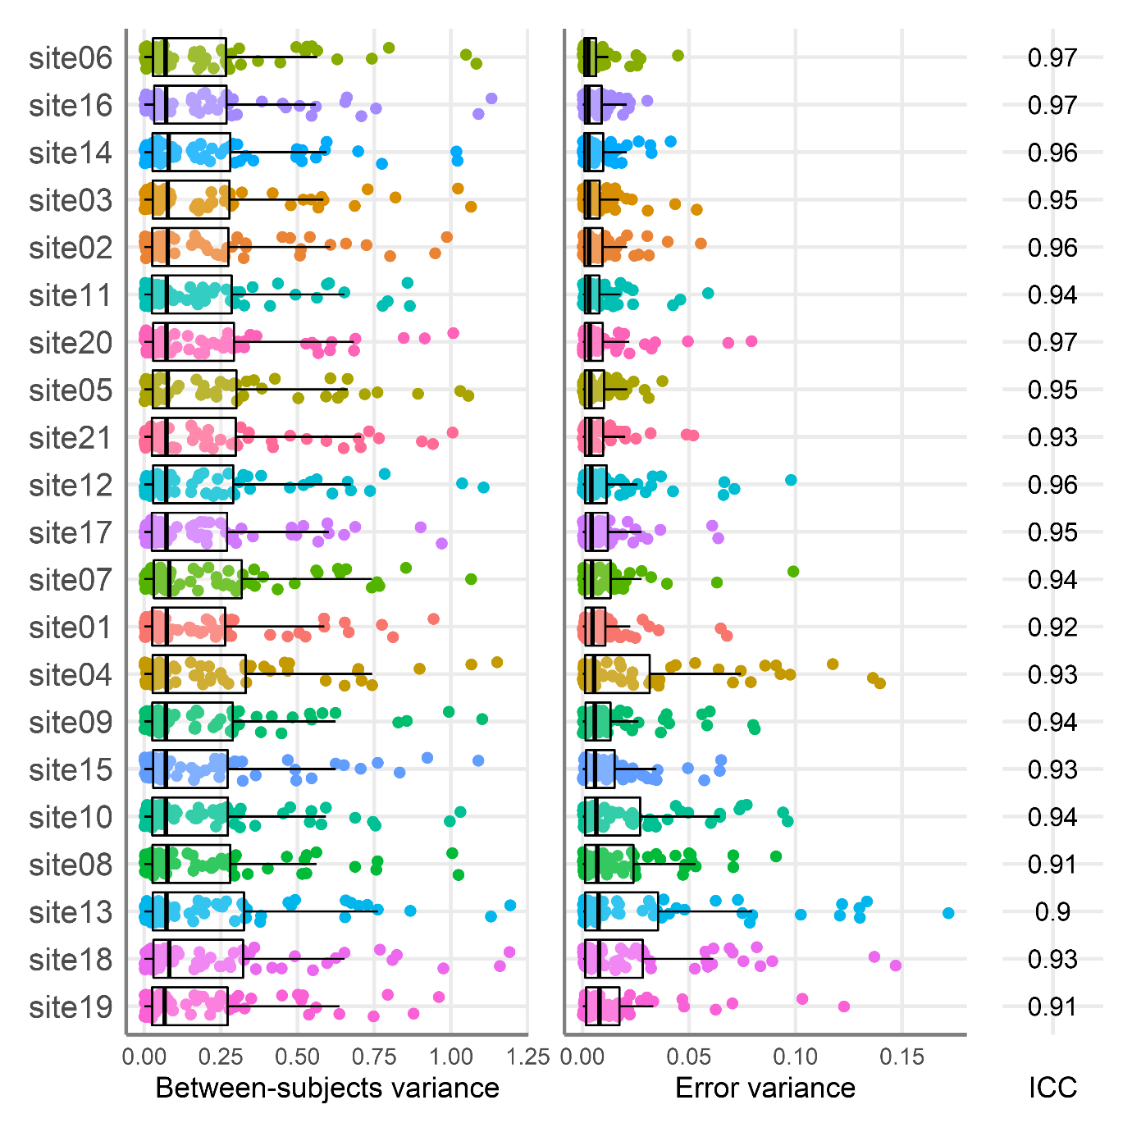

Figure5_SA_scanners.png

Between-subjects (left panel) and error variance (middle panel) estimates for **Surface Area**, **separately per MRI scanner**. **Scanners are ordered by the median error variance**. Each point represents a different ROI, and the site colour maps to Figure 4. Cortical thickness only. The boxplots present the median and the 25th and 75th percentiles, the whiskers extend at a maximum to 1.5 times the interquartile range from the box.

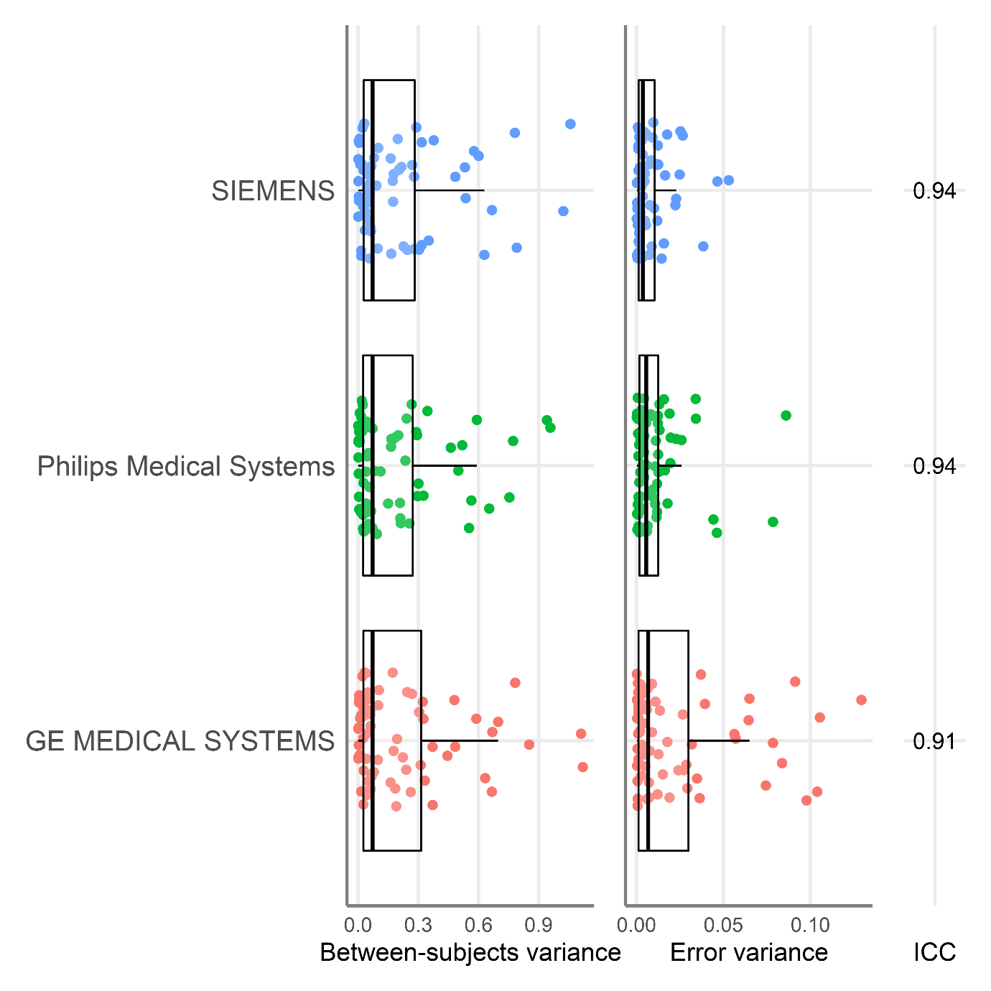

Figure7_CT_ChisquaredLRT.png

**Δ Chi square** for each model comparison (panels A-E) across regions **for Cortical Thickness**. Higher values (lighter and more yellow coloured) indicate improved model fit with more free parameters. In comparisons A and D, between-subject variance is allowed to vary compared to the preceding model. In comparisons B and C, error variance is allowed to vary compared to the preceding model. In panel E both between-subject and error variances are allowed to vary compared to the fully constrained model.

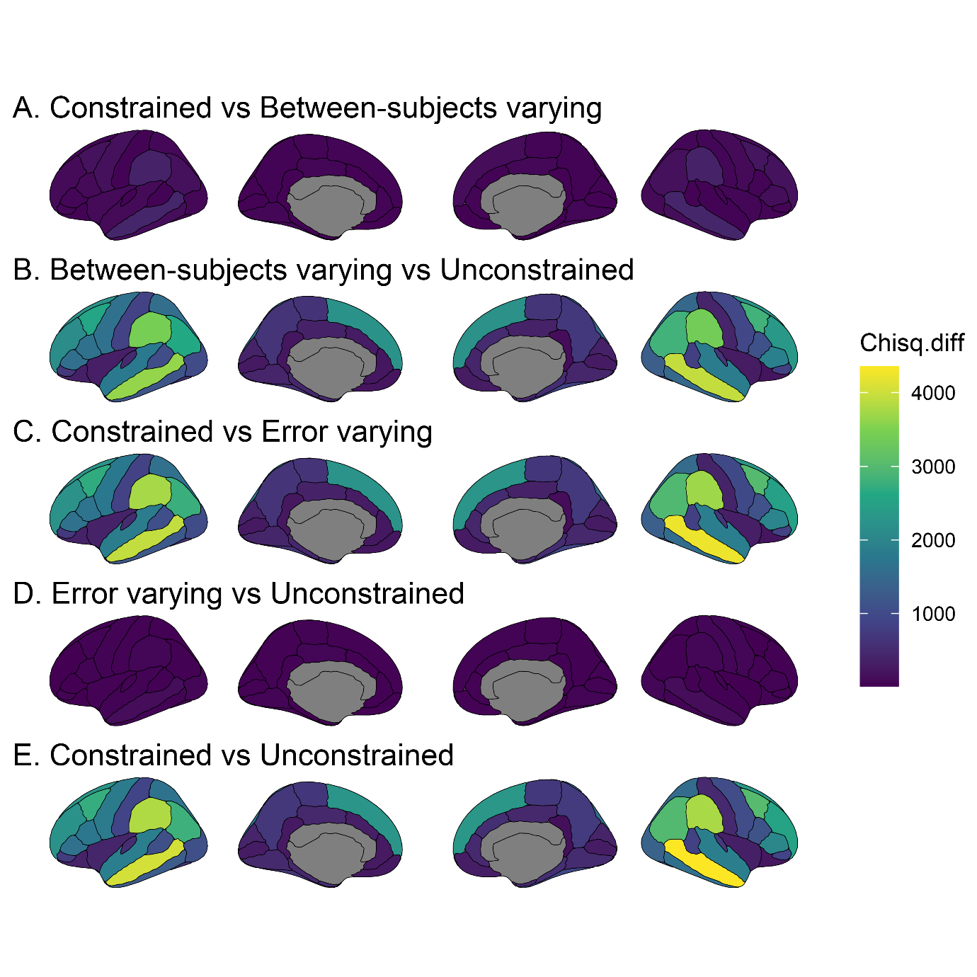

Figure7_CT_deltaAIC.png

**Δ AIC** for each model comparison (panels A-E) across regions **for Cortical Thickness**. Higher values (lighter and more yellow coloured) indicate improved model fit with more free parameters. In comparisons A and D, between-subject variance is allowed to vary compared to the preceding model. In comparisons B and C, error variance is allowed to vary compared to the preceding model. In panel E both between-subject and error variances are allowed to vary compared to the fully constrained model.

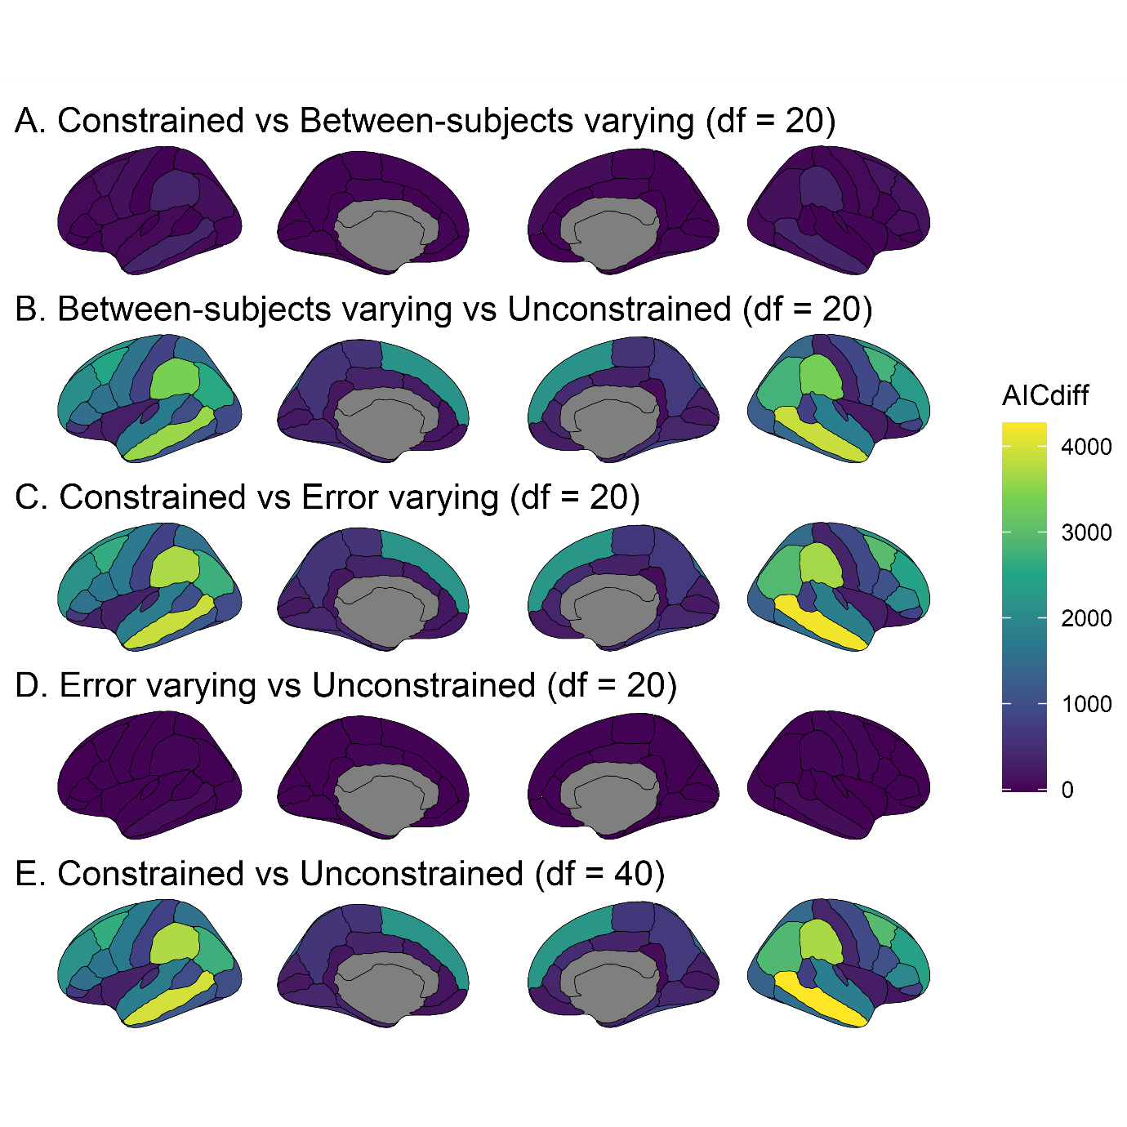

Figure7_CT_deltaBIC.png

**Δ BIC** for each model comparison (panels A-E) across regions **for Cortical Thickness**. Higher values (lighter and more yellow coloured) indicate improved model fit with more free parameters. In comparisons A and D, between-subject variance is allowed to vary compared to the preceding model. In comparisons B and C, error variance is allowed to vary compared to the preceding model. In panel E both between-subject and error variances are allowed to vary compared to the fully constrained model.

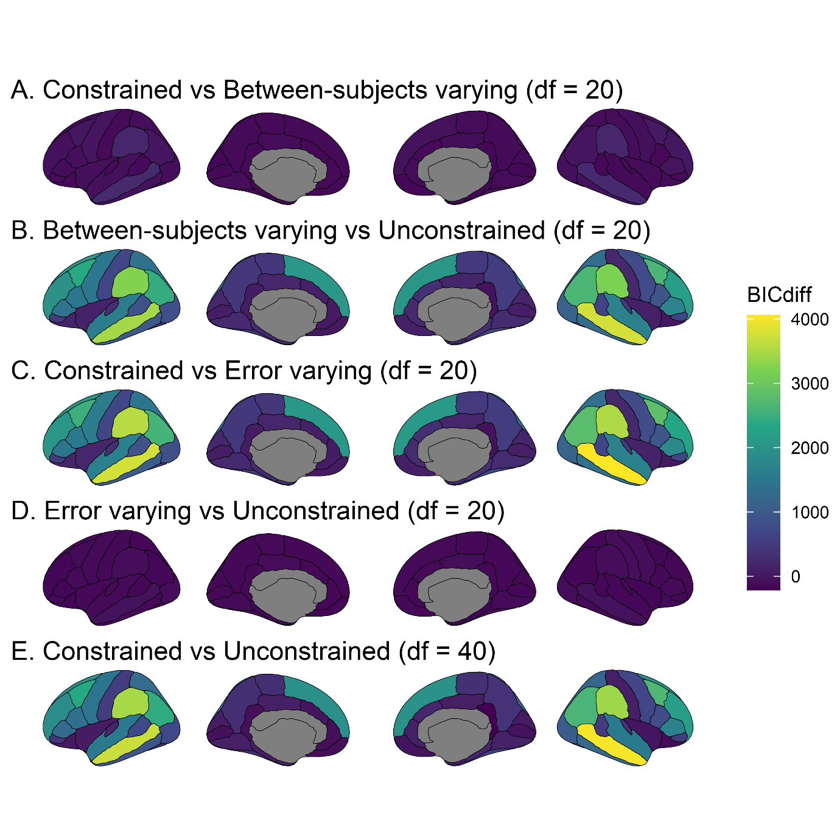

Figure7_CT_GE.png

ΔCFI for each model comparison (panels A-E) across regions **for Cortical Thickness, using only data from testing sites using GE Medical Systems MRI scanners**. Higher values (lighter and more yellow coloured) indicate improved model fit with more free parameters. In comparisons A and D, between-subject variance is allowed to vary compared to the preceding model. In comparisons B and C, error variance is allowed to vary compared to the preceding model. In panel E both between-subject and error variances are allowed to vary compared to the fully constrained model.

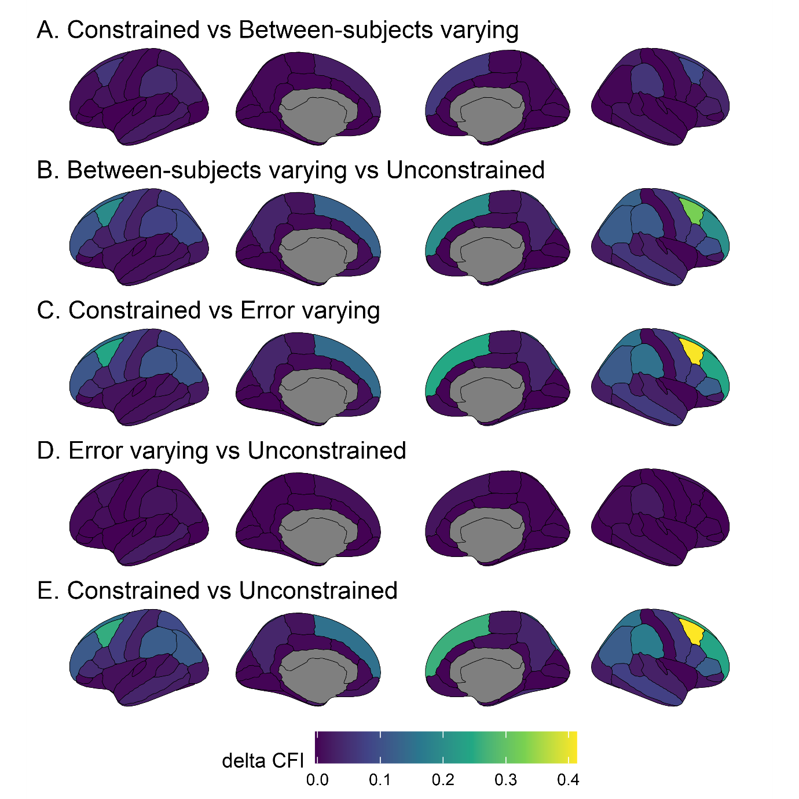

Figure7_CT_Philips.png

ΔCFI for each model comparison (panels A-E) across regions **for Cortical Thickness, using only data from testing sites using Philips Medical Systems MRI scanners**. Higher values (lighter and more yellow coloured) indicate improved model fit with more free parameters. In comparisons A and D, between-subject variance is allowed to vary compared to the preceding model. In comparisons B and C, error variance is allowed to vary compared to the preceding model. In panel E both between-subject and error variances are allowed to vary compared to the fully constrained model.

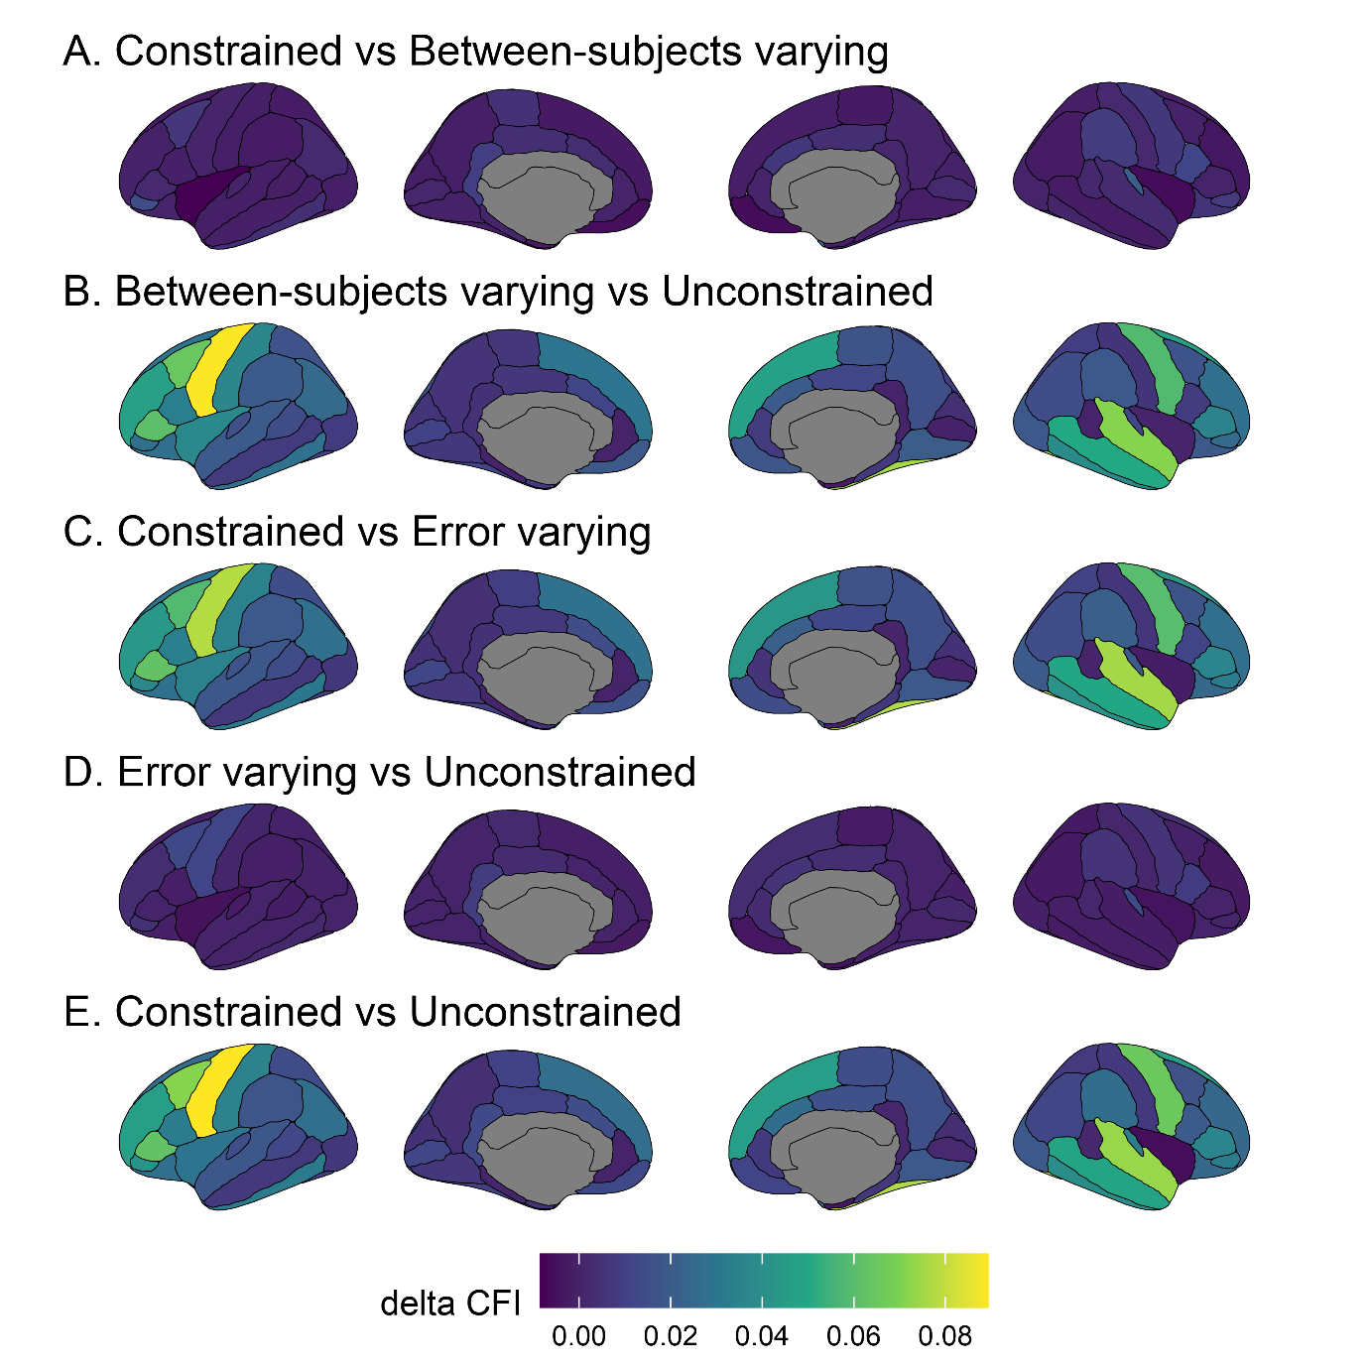

Figure7_CT_scanners.png

ΔCFI for each model comparison (panels A-E) across regions **with MRI scanner as the grouping variable for Cortical Thickness**. Higher values (lighter and more yellow coloured) indicate improved model fit with more free parameters. In comparisons A and D, between-subject variance is allowed to vary compared to the preceding model. In comparisons B and C, error variance is allowed to vary compared to the preceding model. In panel E both between-subject and error variances are allowed to vary compared to the fully constrained model.

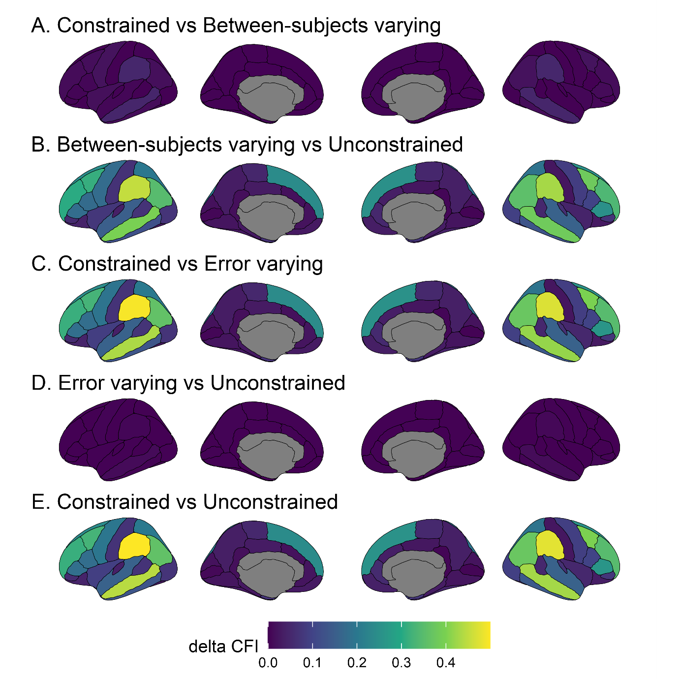

Figure7_CT_Siemens.png

ΔCFI for each model comparison (panels A-E) across regions **for Cortical Thickness, using only data from testing sites using Siemens MRI scanners**. Higher values (lighter and more yellow coloured) indicate improved model fit with more free parameters. In comparisons A and D, between-subject variance is allowed to vary compared to the preceding model. In comparisons B and C, error variance is allowed to vary compared to the preceding model. In panel E both between-subject and error variances are allowed to vary compared to the fully constrained model.



Figure7_GM_ChisquaredLRT.png

**Δ Chi square** for each model comparison (panels A-E) across regions **for Grey Matter Volume**. Higher values (lighter and more yellow coloured) indicate improved model fit with more free parameters. In comparisons A and D, between-subject variance is allowed to vary compared to the preceding model. In comparisons B and C, error variance is allowed to vary compared to the preceding model. In panel E both between-subject and error variances are allowed to vary compared to the fully constrained model.

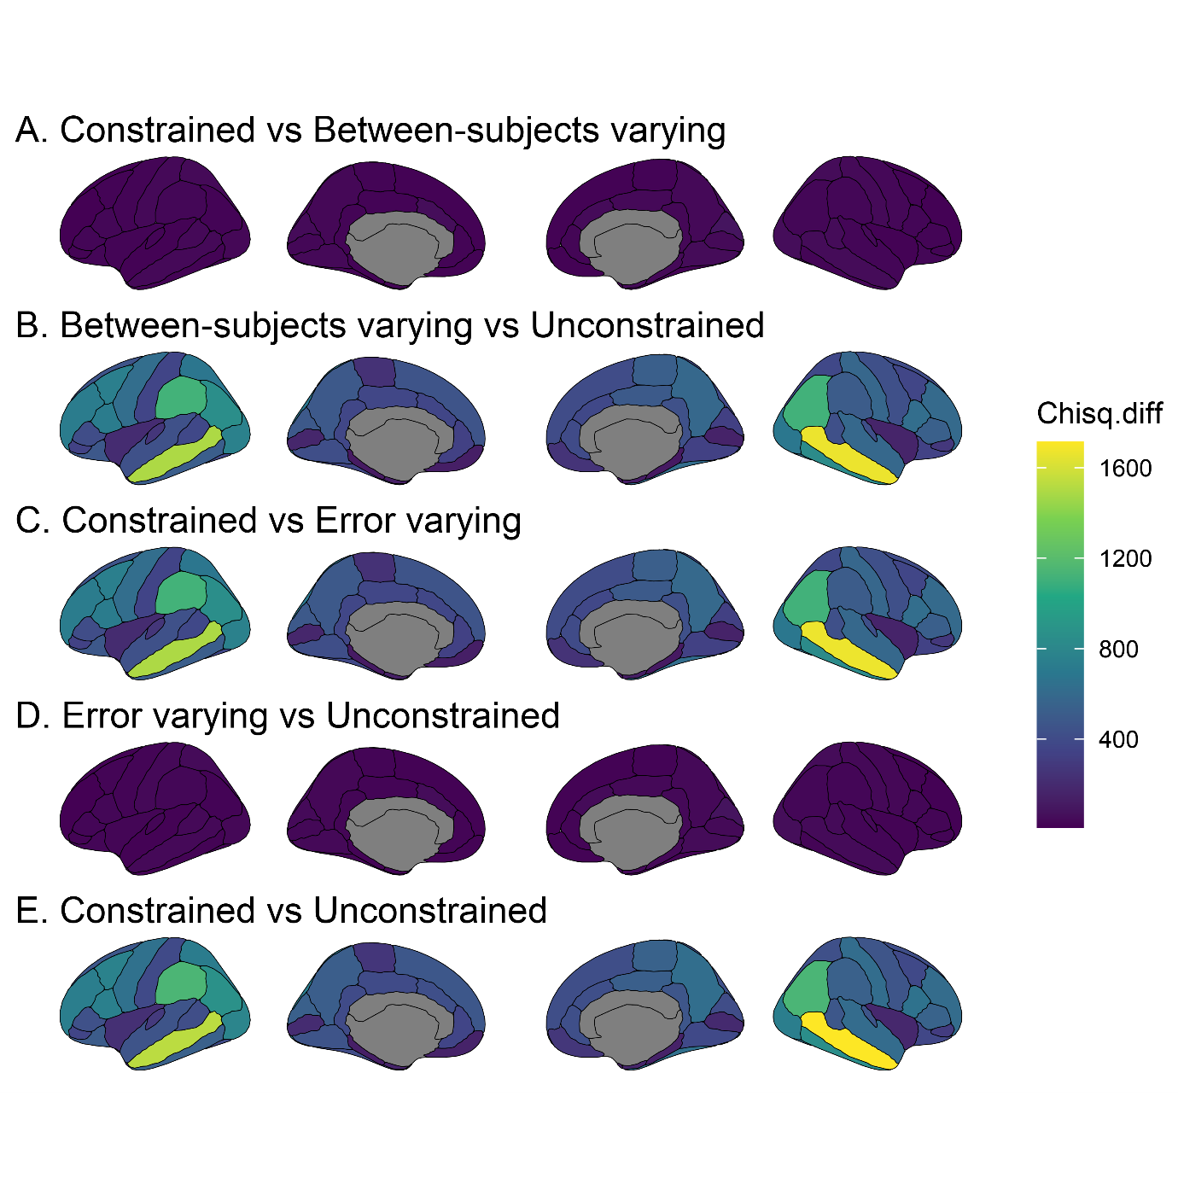

Figure7_GM_deltaAIC.png

**Δ AIC** for each model comparison (panels A-E) across regions **for Grey Matter Volume**. Higher values (lighter and more yellow coloured) indicate improved model fit with more free parameters. In comparisons A and D, between-subject variance is allowed to vary compared to the preceding model. In comparisons B and C, error variance is allowed to vary compared to the preceding model. In panel E both between-subject and error variances are allowed to vary compared to the fully constrained model.

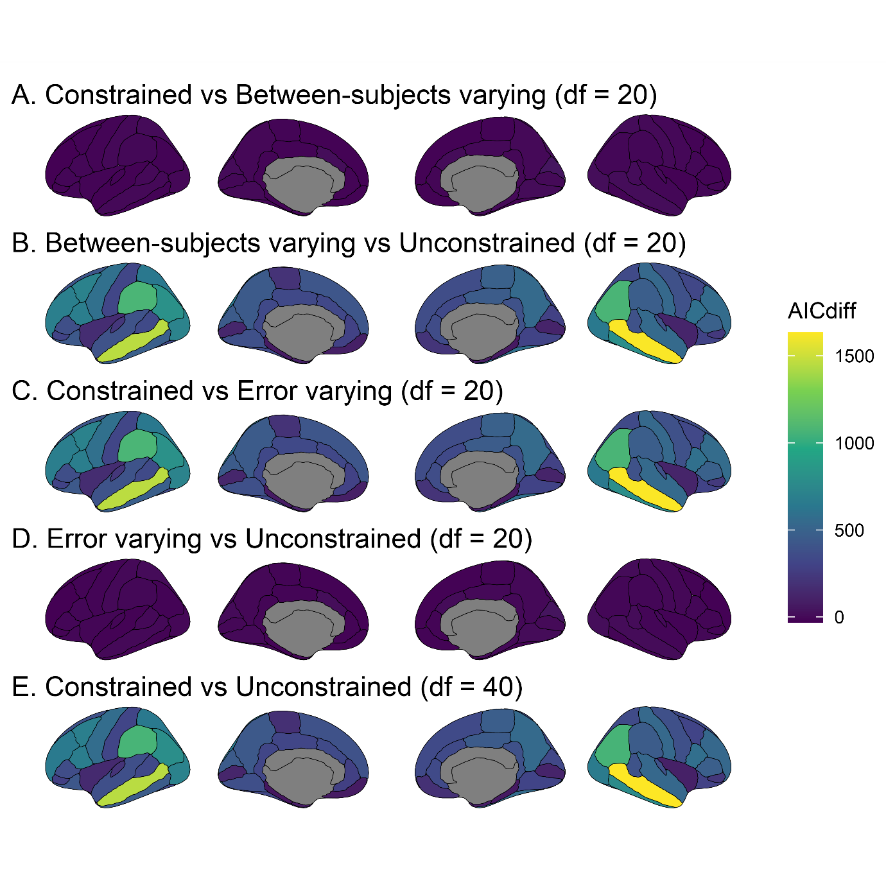

Figure7_GM_deltaBIC.png

**Δ BIC** for each model comparison (panels A-E) across regions **for Grey Matter Volume**. Higher values (lighter and more yellow coloured) indicate improved model fit with more free parameters. In comparisons A and D, between-subject variance is allowed to vary compared to the preceding model. In comparisons B and C, error variance is allowed to vary compared to the preceding model. In panel E both between-subject and error variances are allowed to vary compared to the fully constrained model.

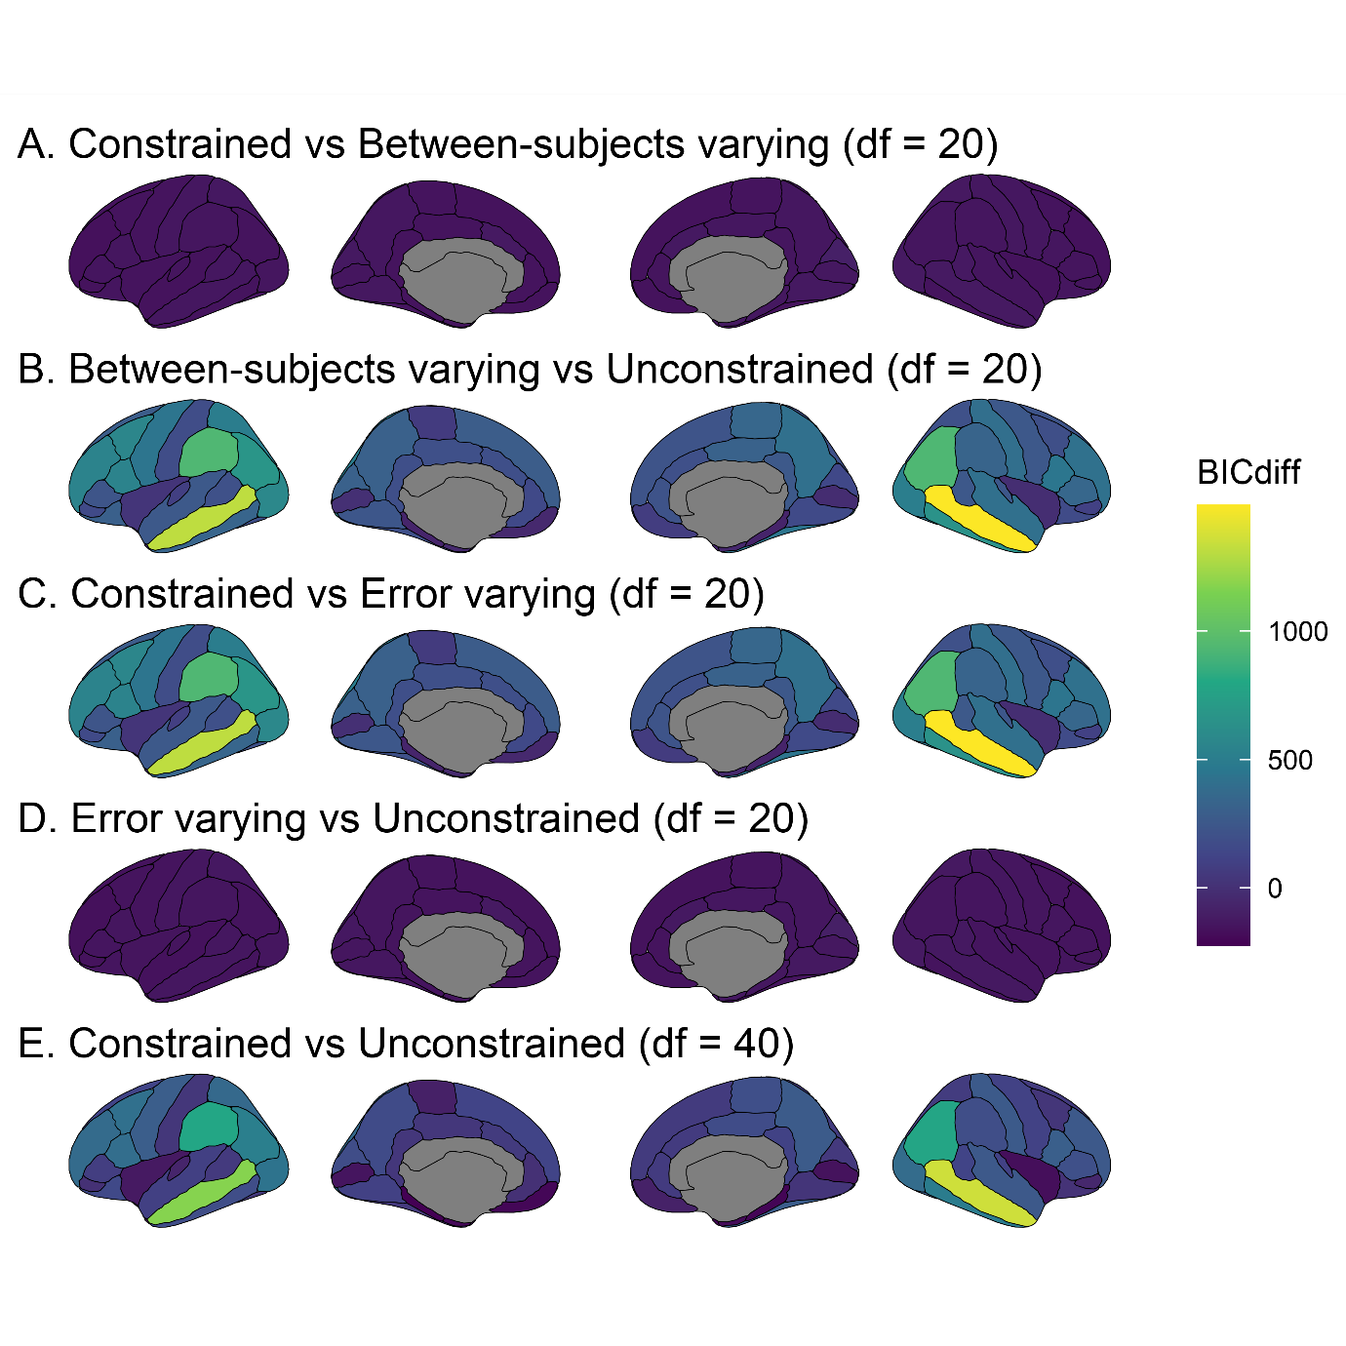

Figure7_GM_deltaCFI.png

**Δ CFI** for each model comparison (panels A-E) across regions **for Grey Matter Volume**. Higher values (lighter and more yellow coloured) indicate improved model fit with more free parameters. In comparisons A and D, between-subject variance is allowed to vary compared to the preceding model. In comparisons B and C, error variance is allowed to vary compared to the preceding model. In panel E both between-subject and error variances are allowed to vary compared to the fully constrained model.

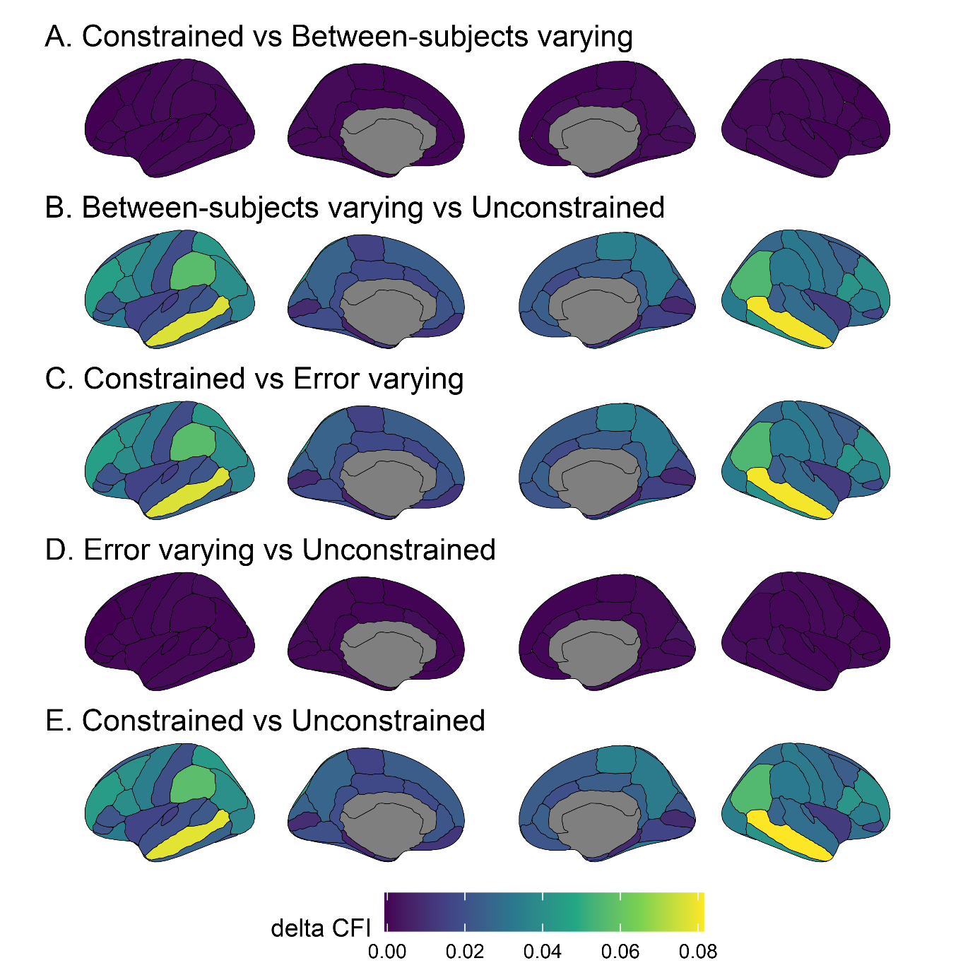

Figure7_GM_GE.png

ΔCFI for each model comparison (panels A-E) across regions **for Grey Matter Volume, using only data from testing sites using GE Medical Systems MRI scanners**. Higher values (lighter and more yellow coloured) indicate improved model fit with more free parameters. In comparisons A and D, between-subject variance is allowed to vary compared to the preceding model. In comparisons B and C, error variance is allowed to vary compared to the preceding model. In panel E both between-subject and error variances are allowed to vary compared to the fully constrained model.

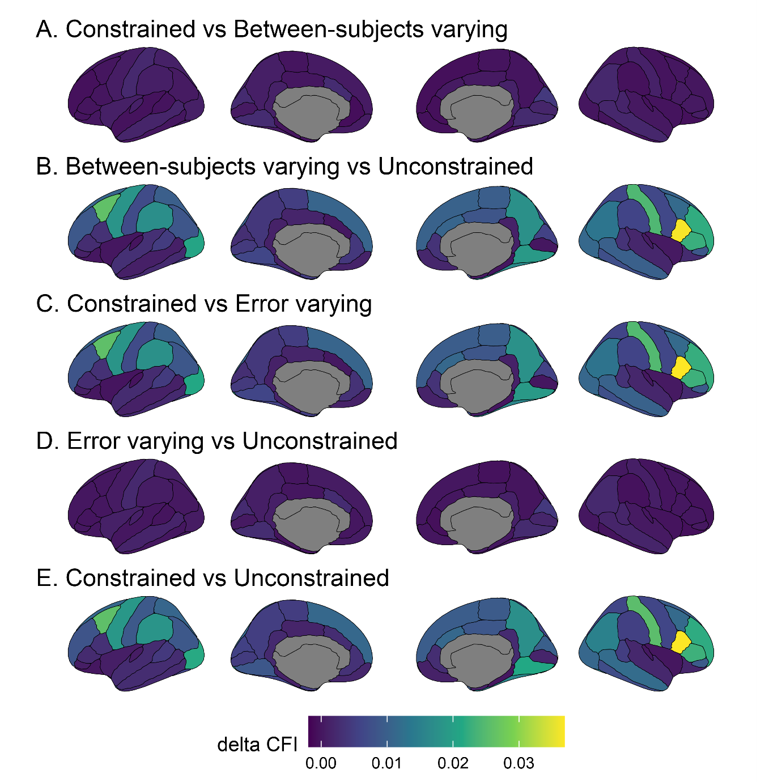

Figure7_GM_Philips.png

ΔCFI for each model comparison (panels A-E) across regions **for Grey Matter Volume, using only data from testing sites using Philips Medical Systems MRI scanners**. Higher values (lighter and more yellow coloured) indicate improved model fit with more free parameters. In comparisons A and D, between-subject variance is allowed to vary compared to the preceding model. In comparisons B and C, error variance is allowed to vary compared to the preceding model. In panel E both between-subject and error variances are allowed to vary compared to the fully constrained model.

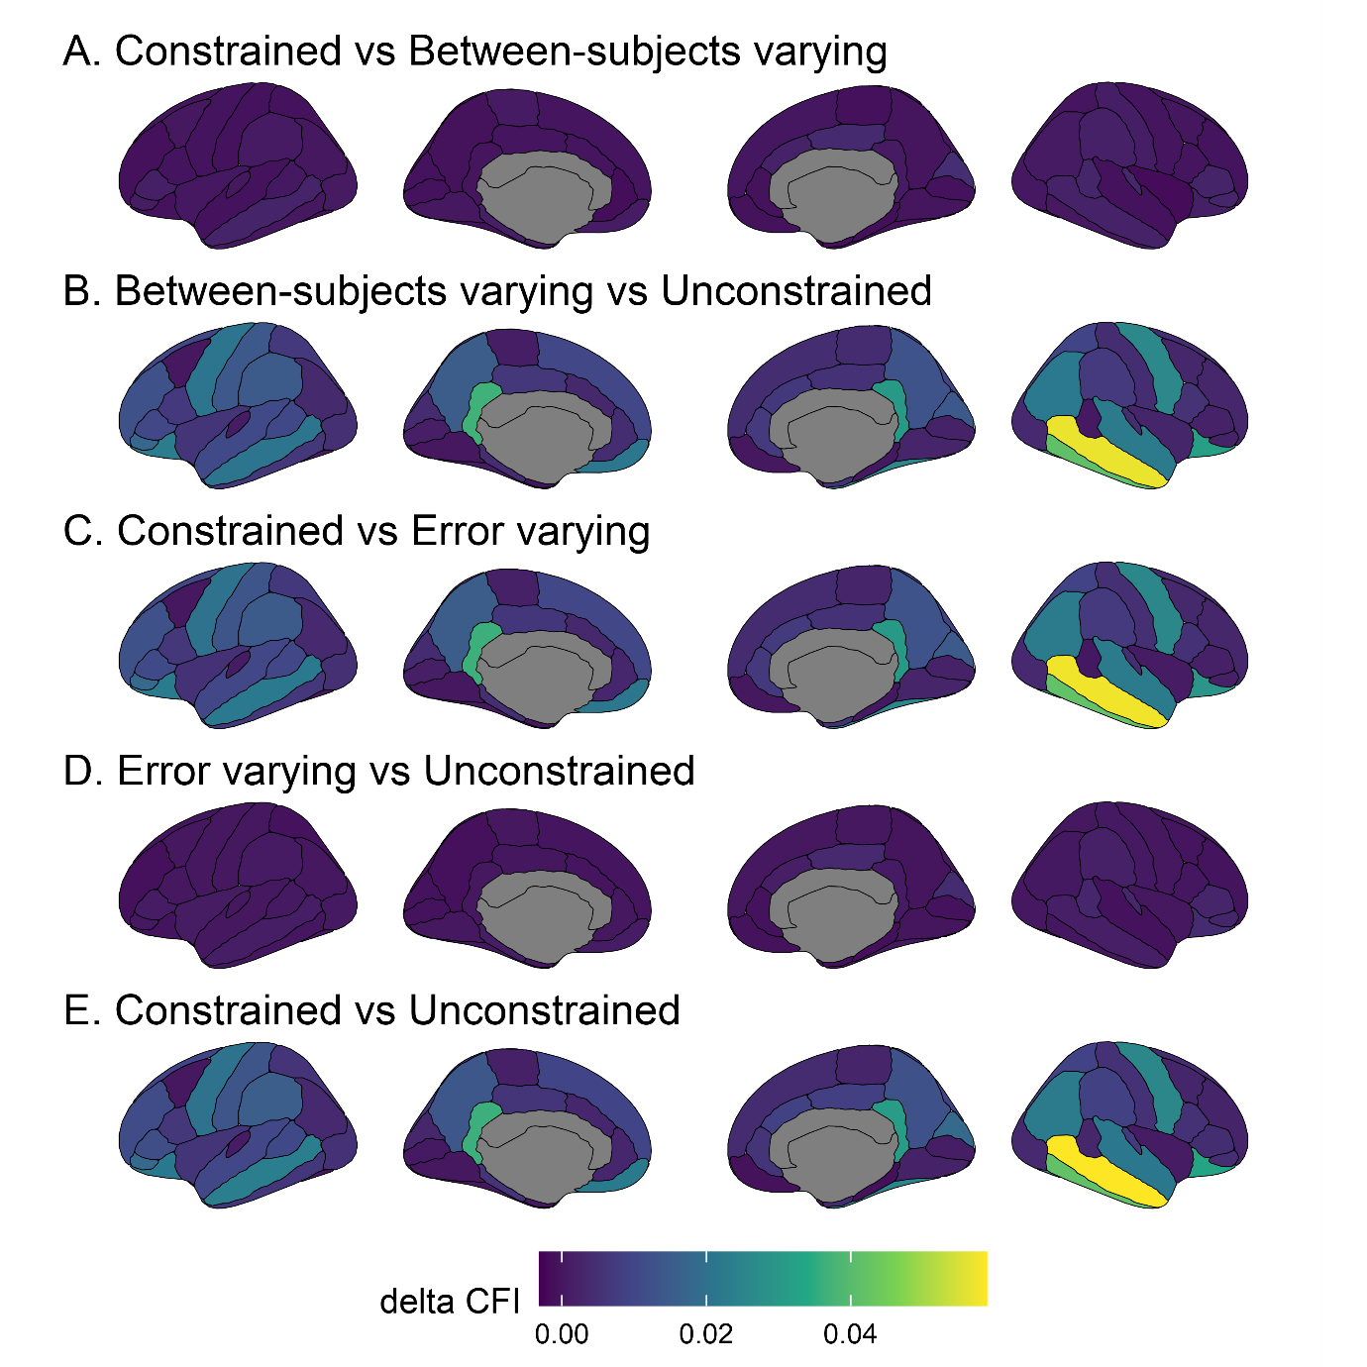

Figure7_GM_scanners.png

ΔCFI for each model comparison (panels A-E) across regions **with MRI scanner as the grouping variable for Grey Matter Volume**. Higher values (lighter and more yellow coloured) indicate improved model fit with more free parameters. In comparisons A and D, between-subject variance is allowed to vary compared to the preceding model. In comparisons B and C, error variance is allowed to vary compared to the preceding model. In panel E both between-subject and error variances are allowed to vary compared to the fully constrained model.

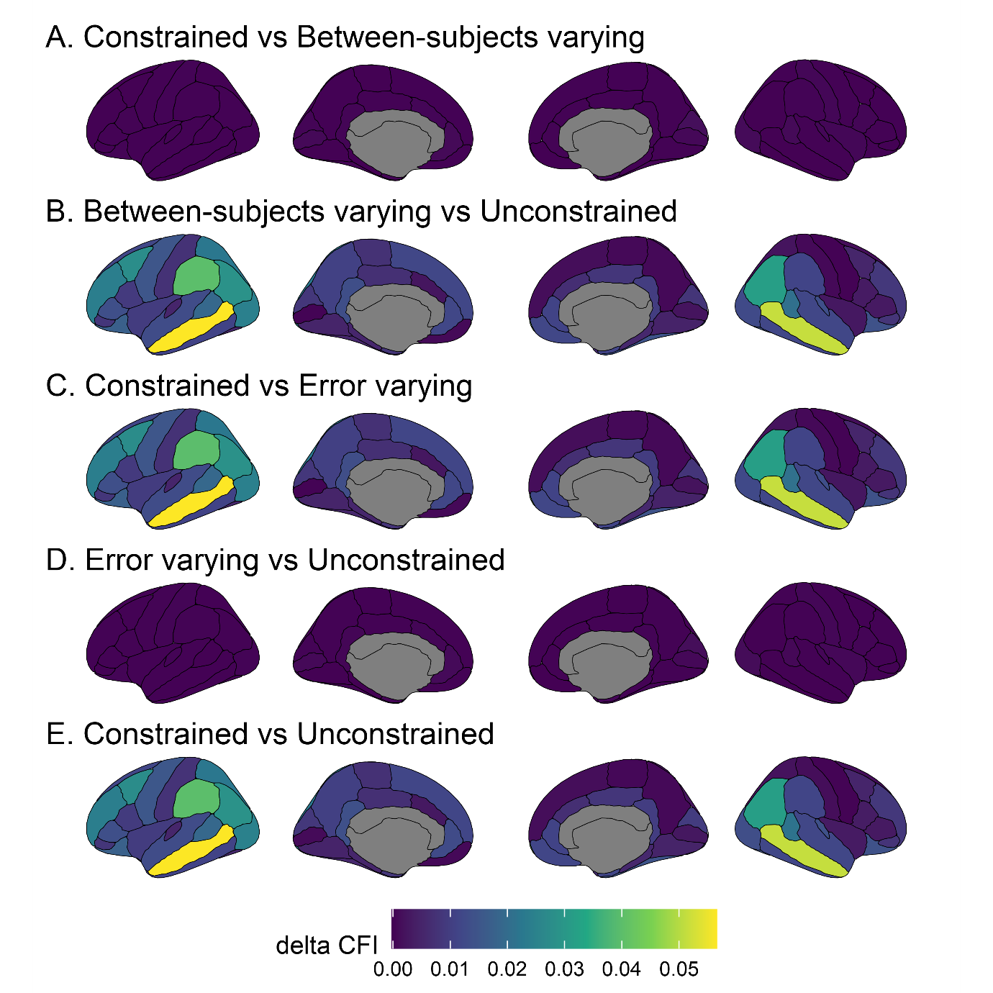

Figure7_GM_Siemens.png

ΔCFI for each model comparison (panels A-E) across regions **for Grey Matter Volume, using only data from testing sites using Siemens MRI scanners**. Higher values (lighter and more yellow coloured) indicate improved model fit with more free parameters. In comparisons A and D, between-subject variance is allowed to vary compared to the preceding model. In comparisons B and C, error variance is allowed to vary compared to the preceding model. In panel E both between-subject and error variances are allowed to vary compared to the fully constrained model.

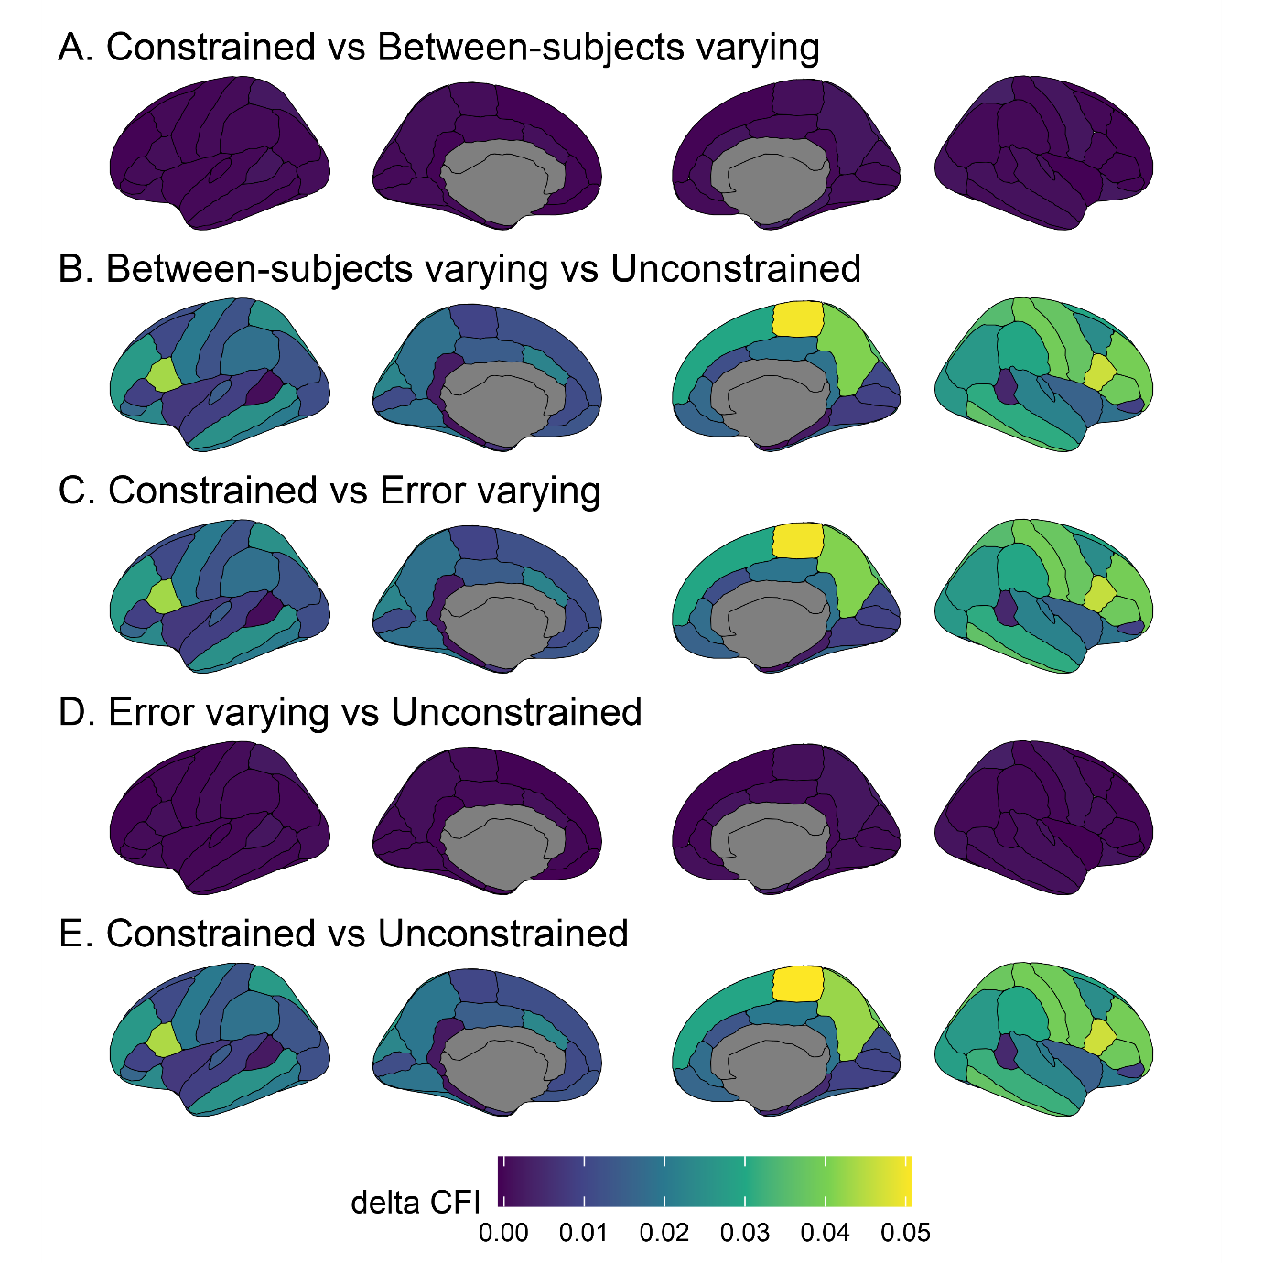

Figure7_SA_ChisquaredLRT.png

**Δ Chi square** for each model comparison (panels A-E) across regions **for Surface Area**. Higher values (lighter and more yellow coloured) indicate improved model fit with more free parameters. In comparisons A and D, between-subject variance is allowed to vary compared to the preceding model. In comparisons B and C, error variance is allowed to vary compared to the preceding model. In panel E both between-subject and error variances are allowed to vary compared to the fully constrained model.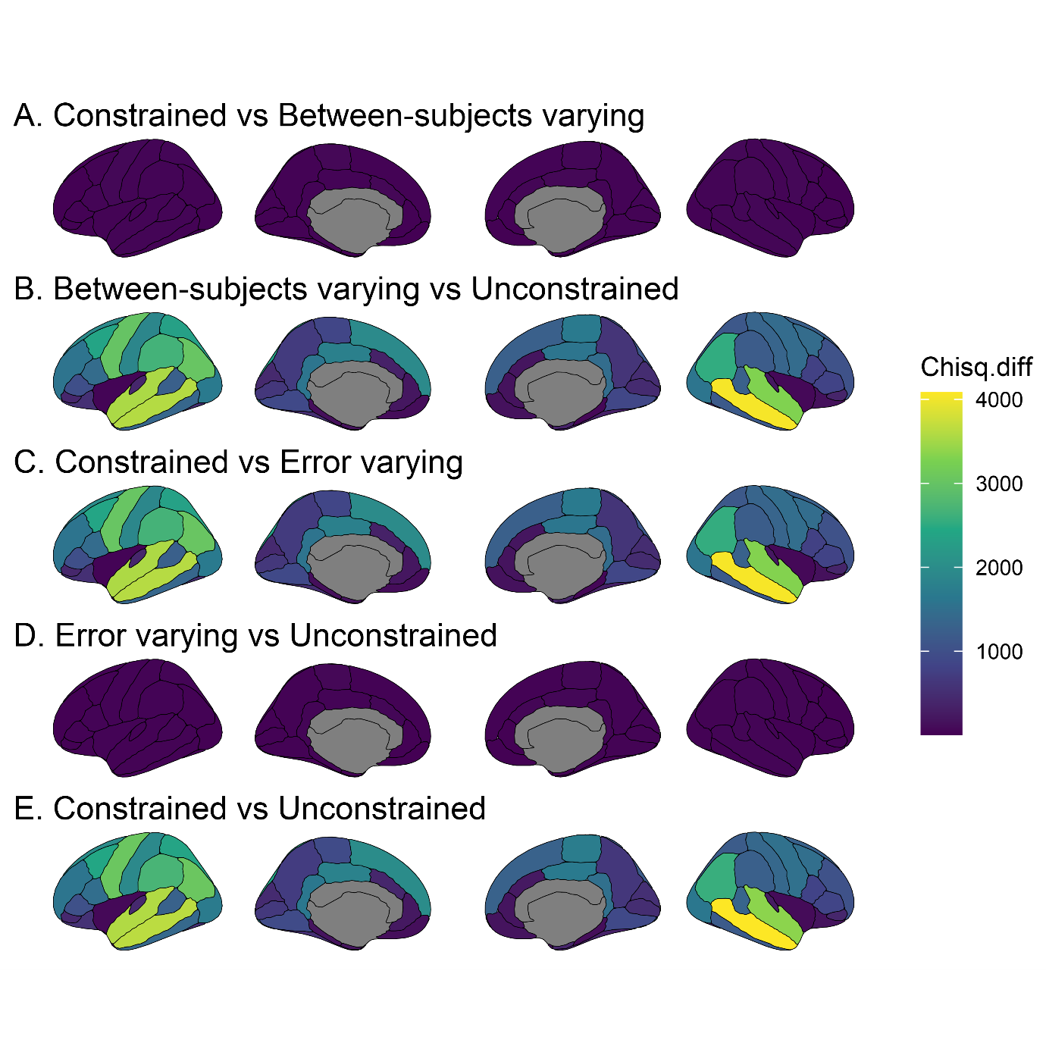

Figure7_SA_deltaAIC.png

**Δ AIC** for each model comparison (panels A-E) across regions **for Surface Area**. Higher values (lighter and more yellow coloured) indicate improved model fit with more free parameters. In comparisons A and D, between-subject variance is allowed to vary compared to the preceding model. In comparisons B and C, error variance is allowed to vary compared to the preceding model. In panel E both between-subject and error variances are allowed to vary compared to the fully constrained model.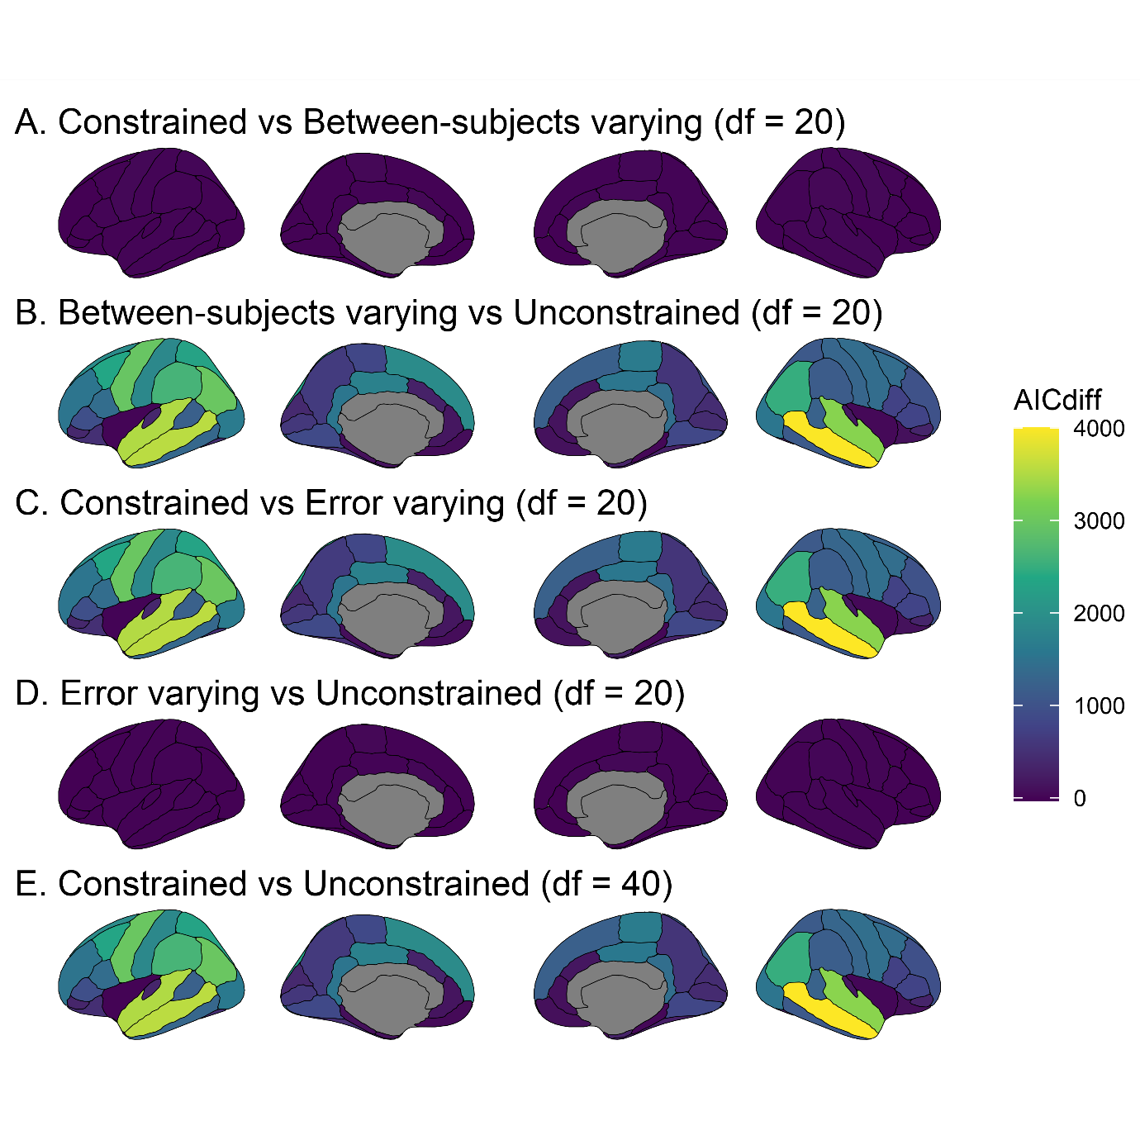

Figure7_SA_deltaBIC.png

**Δ BIC** for each model comparison (panels A-E) across regions **for Surface Area**. Higher values (lighter and more yellow coloured) indicate improved model fit with more free parameters. In comparisons A and D, between-subject variance is allowed to vary compared to the preceding model. In comparisons B and C, error variance is allowed to vary compared to the preceding model. In panel E both between-subject and error variances are allowed to vary compared to the fully constrained model.

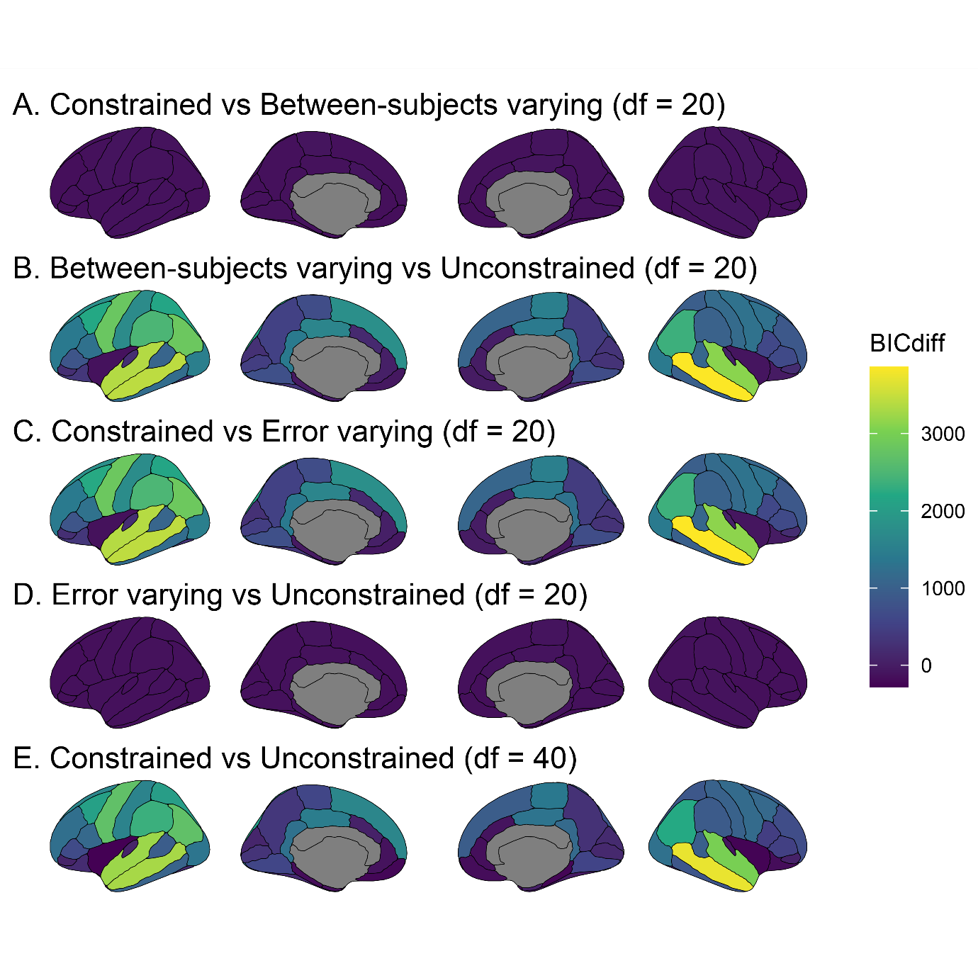

Figure7_SA_deltaCFI.png

**Δ CFI** for each model comparison (panels A-E) across regions **for Surface Area**. Higher values (lighter and more yellow coloured) indicate improved model fit with more free parameters. In comparisons A and D, between-subject variance is allowed to vary compared to the preceding model. In comparisons B and C, error variance is allowed to vary compared to the preceding model. In panel E both between-subject and error variances are allowed to vary compared to the fully constrained model.

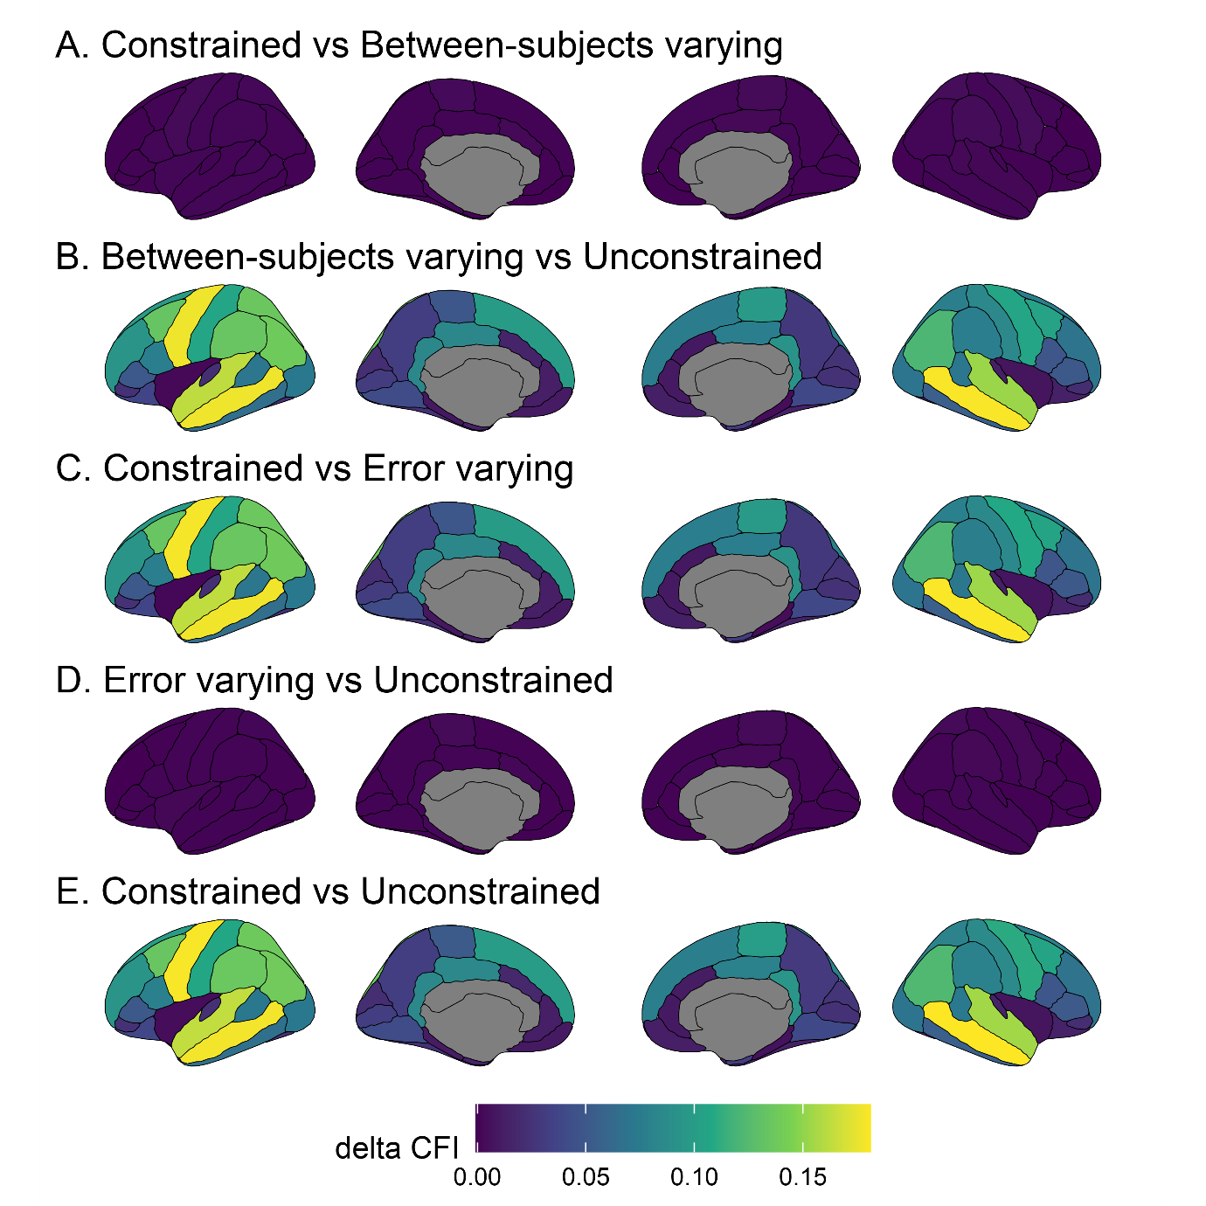

Figure7_SA_GE.png

ΔCFI for each model comparison (panels A-E) across regions **for Surface Area, using only data from testing sites using GE Medical Systems MRI scanners**. Higher values (lighter and more yellow coloured) indicate improved model fit with more free parameters. In comparisons A and D, between-subject variance is allowed to vary compared to the preceding model. In comparisons B and C, error variance is allowed to vary compared to the preceding model. In panel E both between-subject and error variances are allowed to vary compared to the fully constrained model.

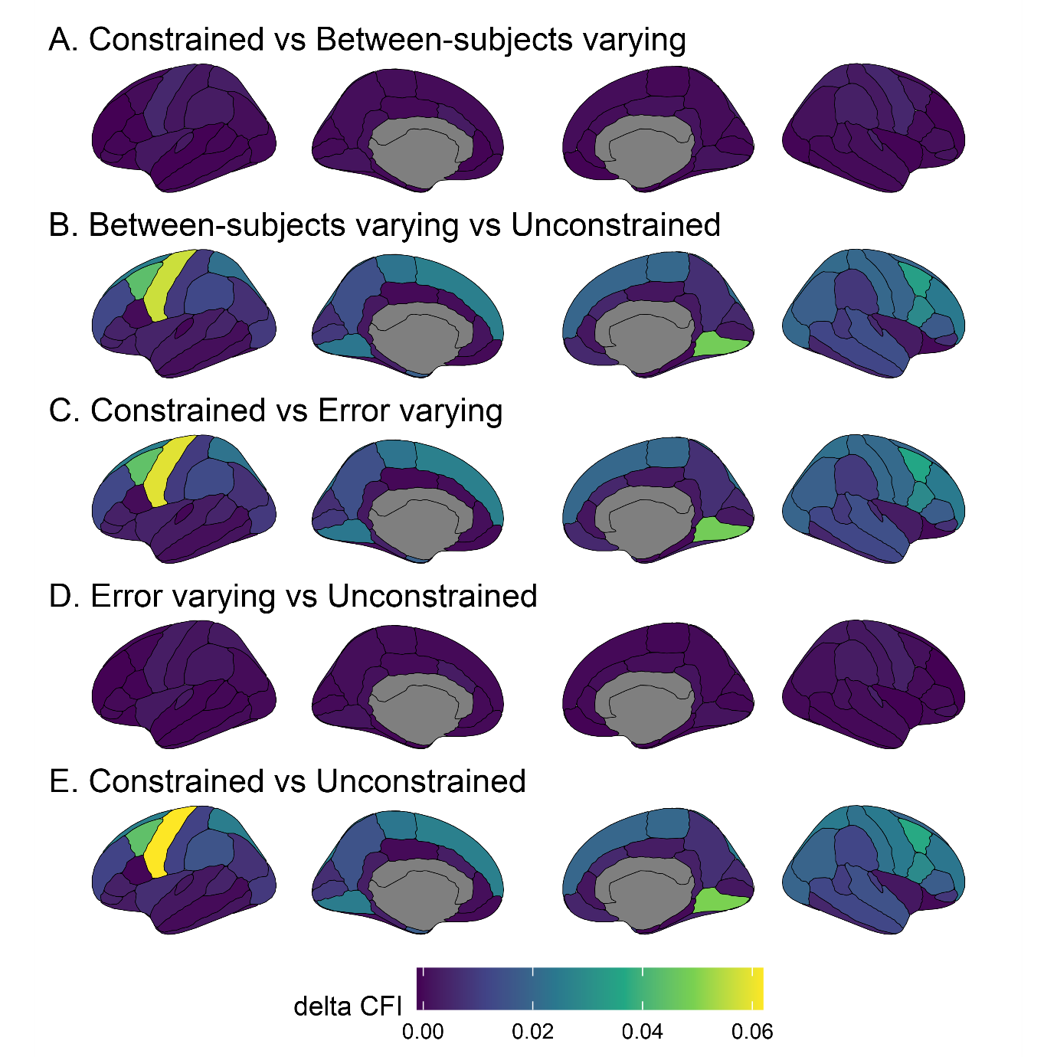

Figure7_SA_Philips.png

ΔCFI for each model comparison (panels A-E) across regions **for Surface Area, using only data from testing sites using Philips Medical Systems MRI scanners**. Higher values (lighter and more yellow coloured) indicate improved model fit with more free parameters. In comparisons A and D, between-subject variance is allowed to vary compared to the preceding model. In comparisons B and C, error variance is allowed to vary compared to the preceding model. In panel E both between-subject and error variances are allowed to vary compared to the fully constrained model.

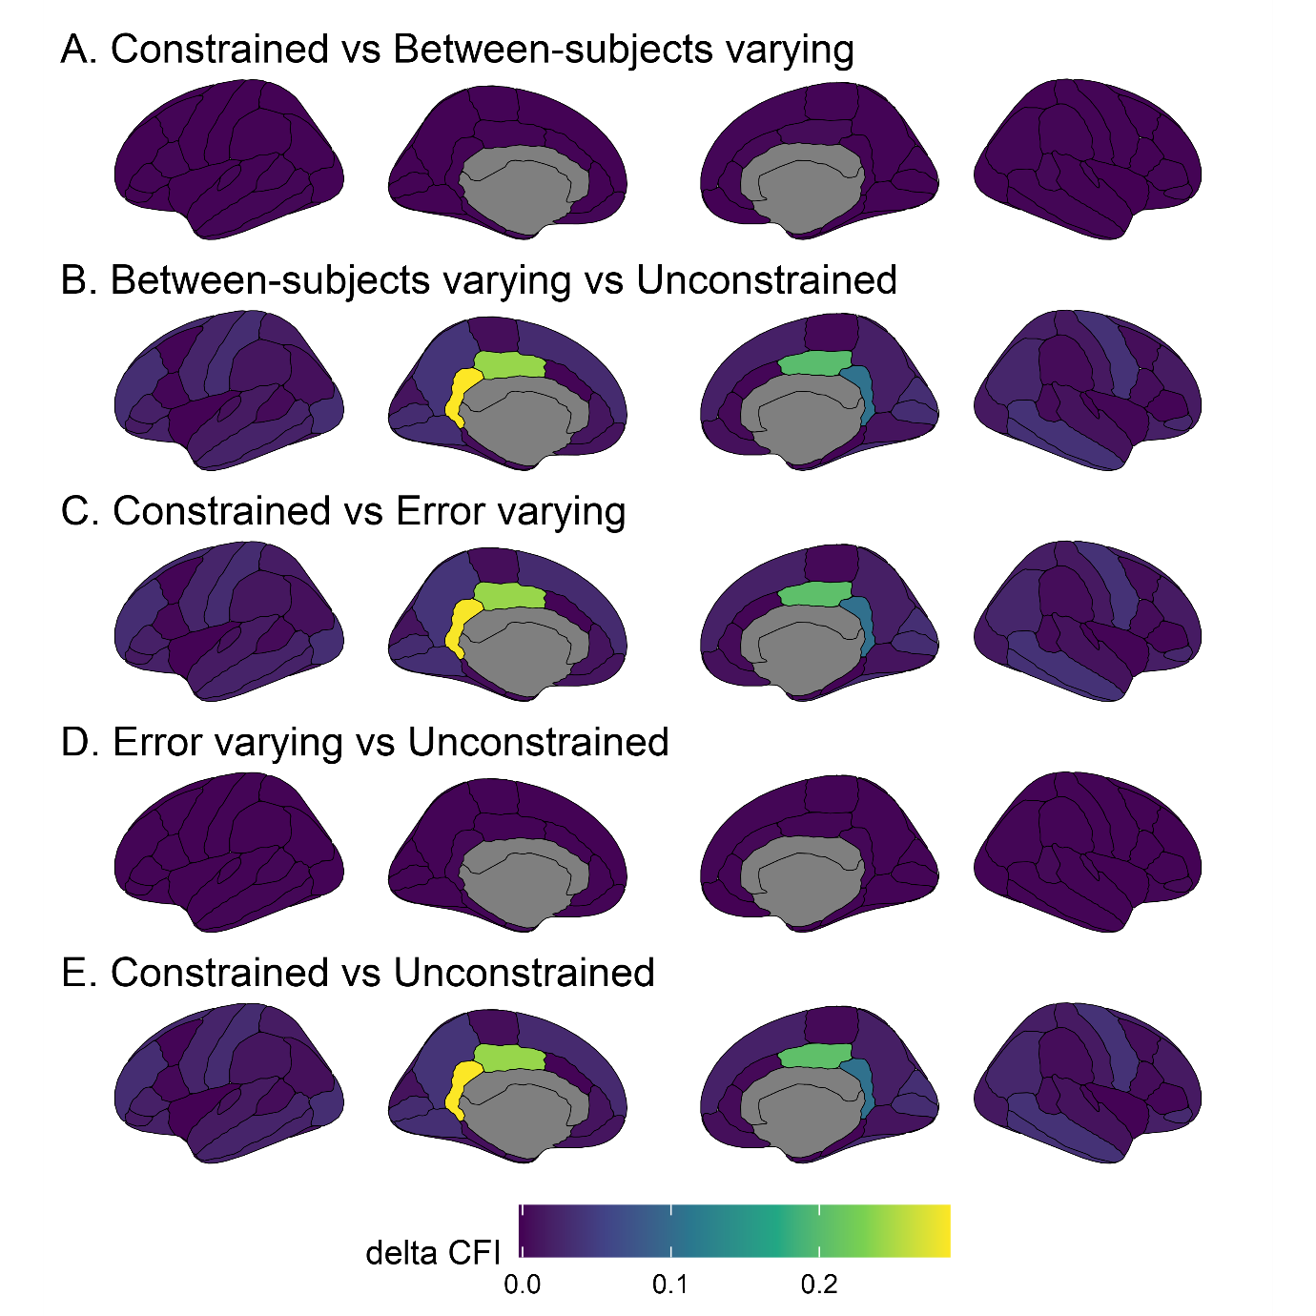

Figure7_SA_scanners.png

ΔCFI for each model comparison (panels A-E) across regions **with MRI scanner as the grouping variable for Surface Area**. Higher values (lighter and more yellow coloured) indicate improved model fit with more free parameters. In comparisons A and D, between-subject variance is allowed to vary compared to the preceding model. In comparisons B and C, error variance is allowed to vary compared to the preceding model. In panel E both between-subject and error variances are allowed to vary compared to the fully constrained model.

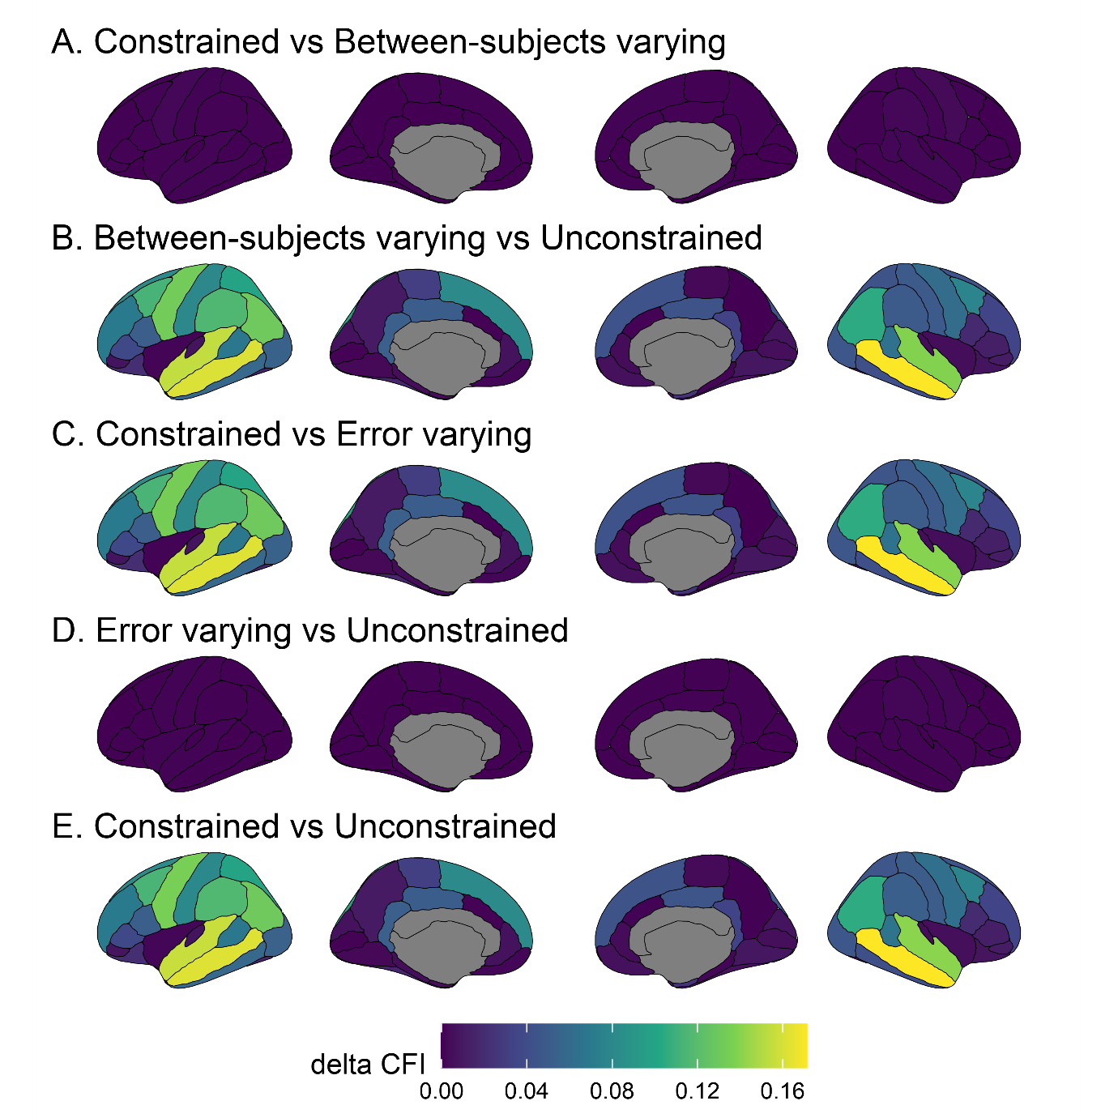

Figure7_SA_Siemens.png

ΔCFI for each model comparison (panels A-E) across regions **for Surface Area, using only data from testing sites using Siemens MRI scanners**. Higher values (lighter and more yellow coloured) indicate improved model fit with more free parameters. In comparisons A and D, between-subject variance is allowed to vary compared to the preceding model. In comparisons B and C, error variance is allowed to vary compared to the preceding model. In panel E both between-subject and error variances are allowed to vary compared to the fully constrained model.

